Sara Jane (Sally) and Mary Elizabeth Aloia,
Daughters of Giuseppe Joseph Aloia
& Letizia (Daisy) Martino Aloia

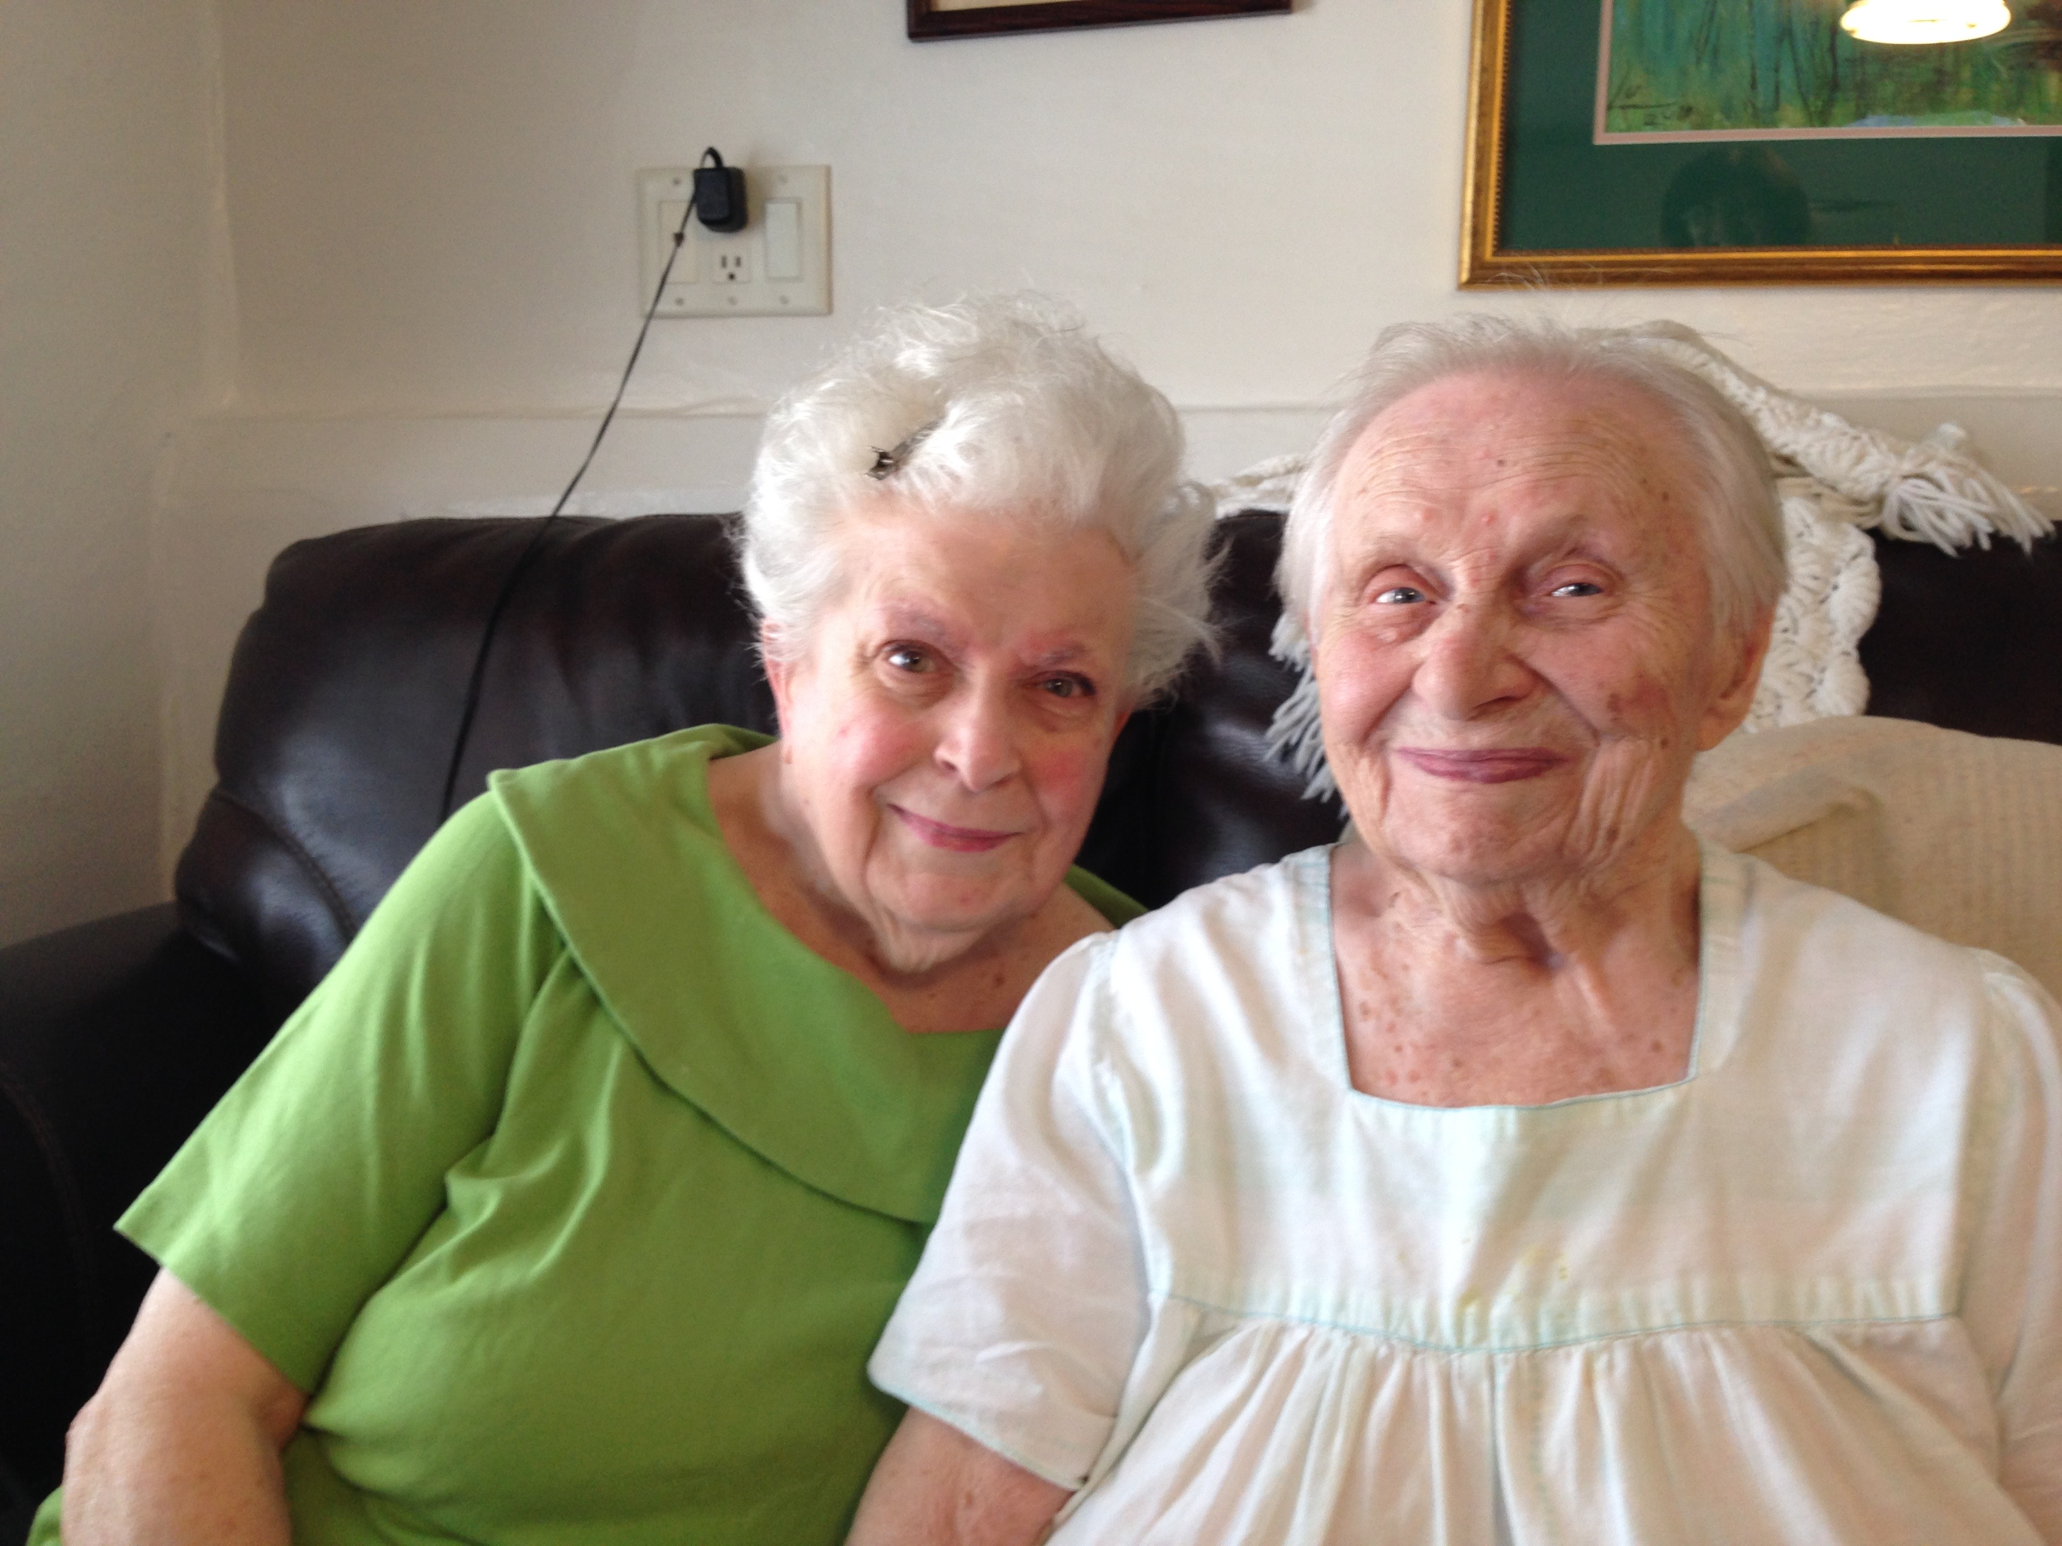
Sally and Mary Aloia.

This is an interview with sisters Sara Jane (Sally) and Mary Elizabeth Aloia, who grew up with their six siblings on Houston and Rural streets on the hillside, south of East Maiden Street in Washington, PA. Their hardworking parents, Giuseppe Joseph Aloia and Letizia (Daisy) Martino Aloia, made a name for themselves with their hillside farm that not only fed their family but the also community through farmers markets and door-to-door sales. “Everything we ate came from the garden,” Mary said. “Only flour, sugar and oil came from the store.”

Giuseppe emigrated to Washington around 1908. After Giuseppe’s mother died, his father Domenico and his siblings also came to Washington. They lived on lower East Prospect Avenue, a popular street for Italians. One day, Giuseppe saw a photograph of Letizia Martino of Bellosquardo, Province of Salerno, Naples, in the home of one of his Italian neighbors, who was Letizia’s aunt. Based only on her photograph, Giuseppe proclaimed, “I want to marry her.” In 1914 he did exactly that, marrying Letizia at Immaculate Conception Church.

Like many other Italians who emigrated to the United States, Giuseppe and Letizia sought opportunities that were lacking in poverty-stricken southern Italy. Washington was an obvious choice of location for Giuseppe because many other families had settled here from his hometown of Aquara, Province of Salerno, Naples. In fact, Aquara and Bellosquardo are among the most common Italian hometowns represented in the city of Washington.

Like most immigrants, Giuseppe and Letizia struggled to make a living in their new country. They and their children pulled together to farm, sell produce and take care of the home. Early on, the family faced the typical discrimination against Italians, but the family thrived through perseverance and hard work, and acceptance came over time. In 1953, Sally became one of several Italian Americans who went to work at Bell Telephone. Mary was employed as a clerk at Taylor’s Pharmacy in the George Washington Hotel for 32 years. Their nephew George Chicora was the first Italian American to work for the Washington Observer-Reporter.
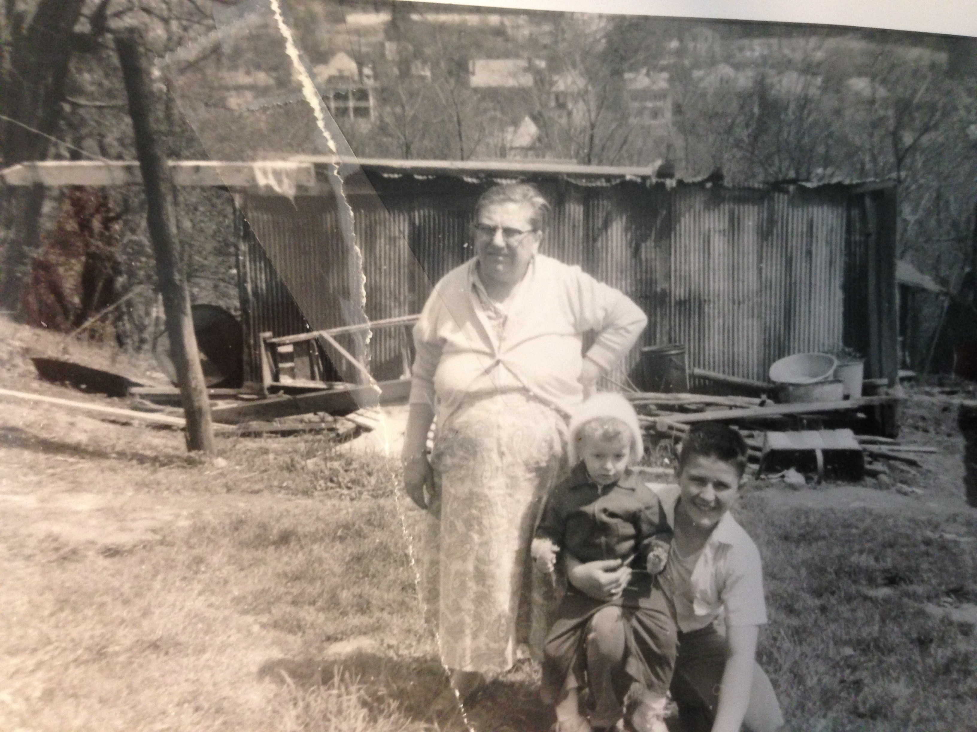
Today, Sally and Mary pride themselves on the cooking and gardening skills their parents instilled in their family. They are surrounded by 18 nieces and nephews, as well as numerous great nieces and nephews. The sisters spend their days together, enjoy the company of relatives who stop by frequently, and keep true to their Italian traditions.

Virginia Marchese Aloia (grandmother of Mary and Sally Aloia) with grandchildren Lou Ann Aloia and George Chicora.
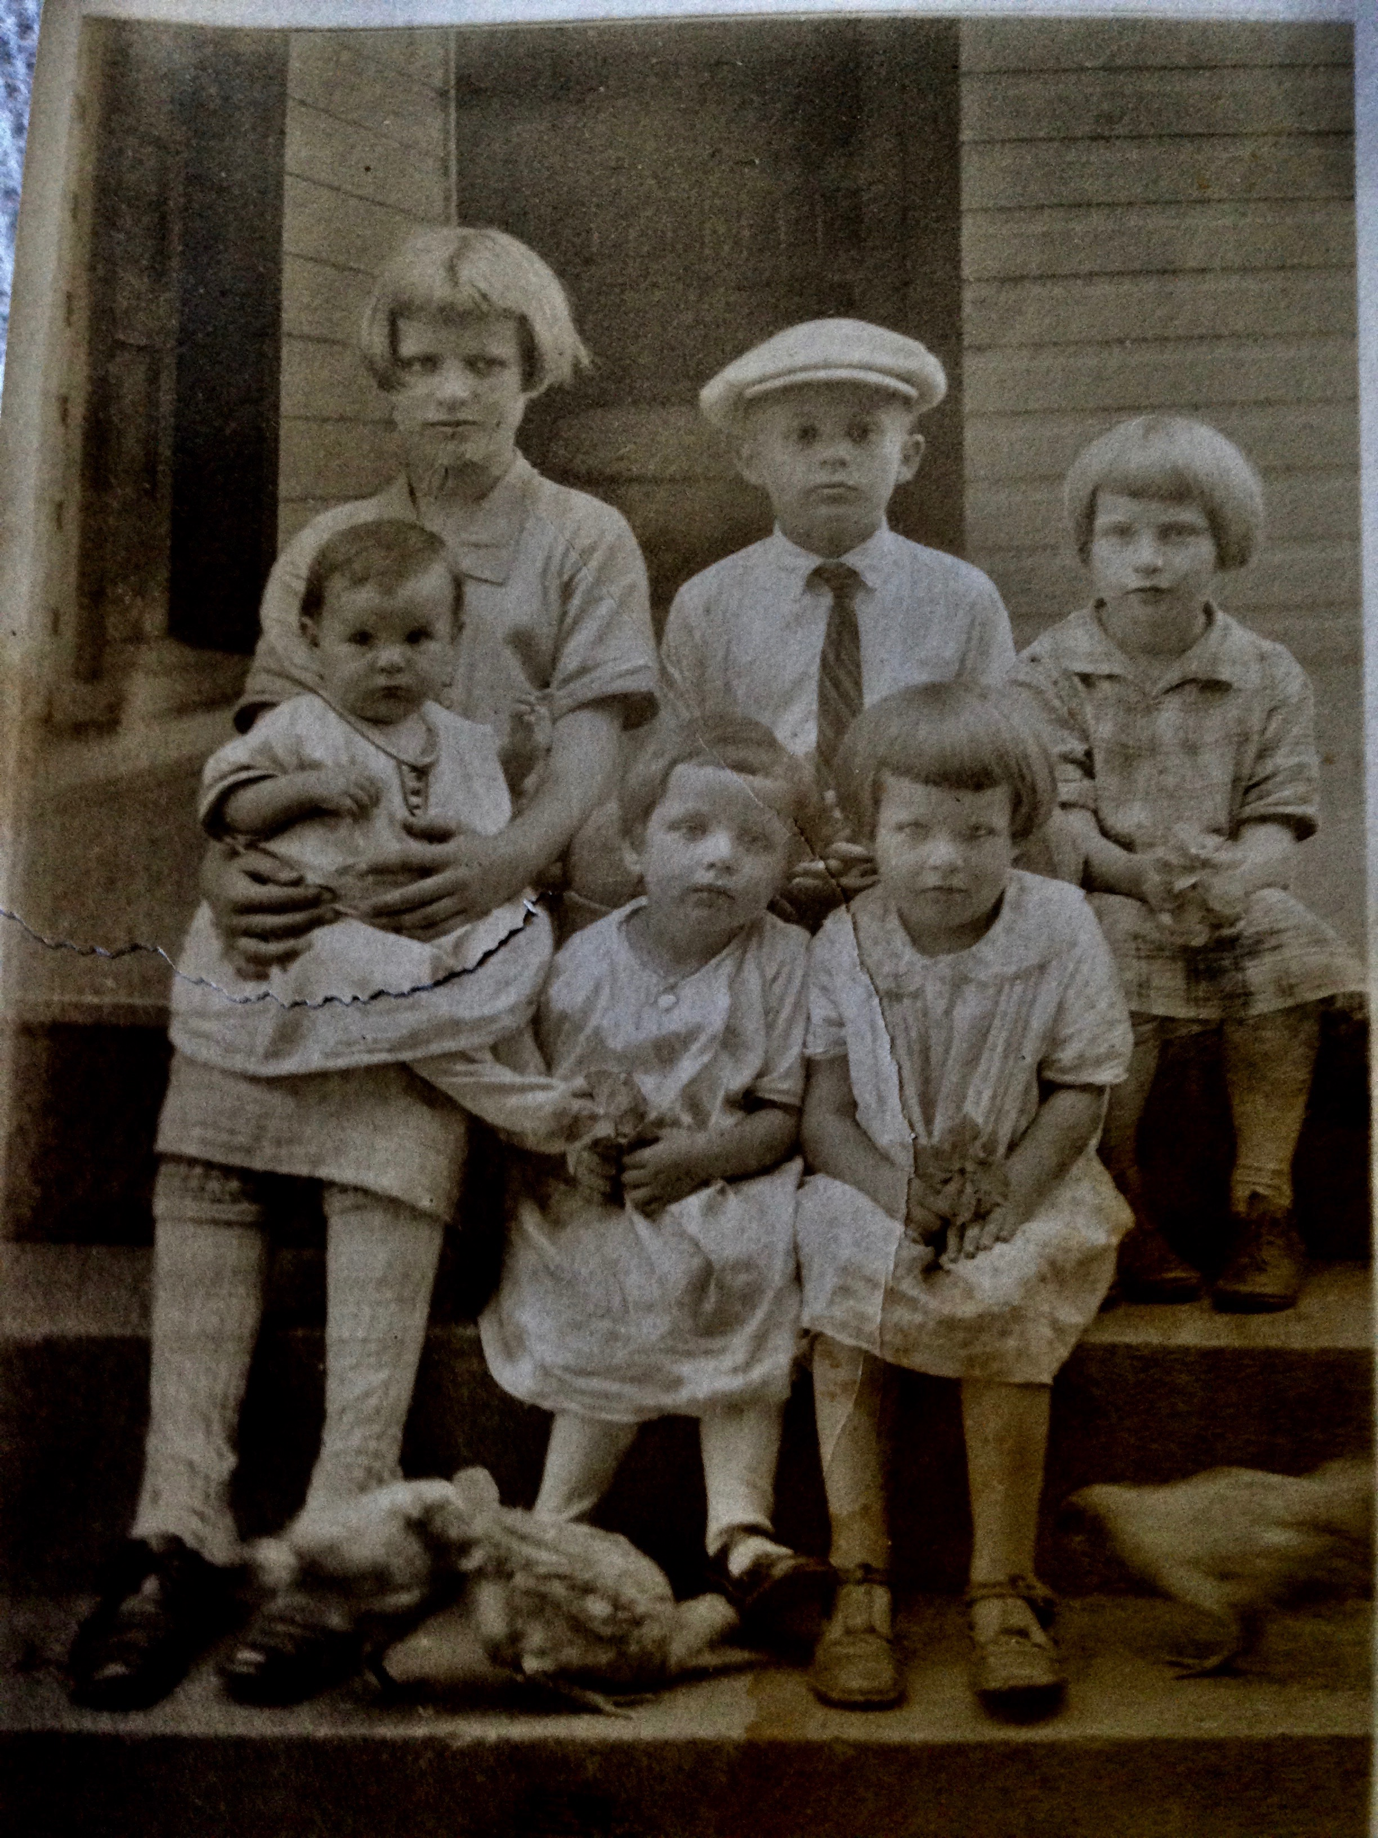
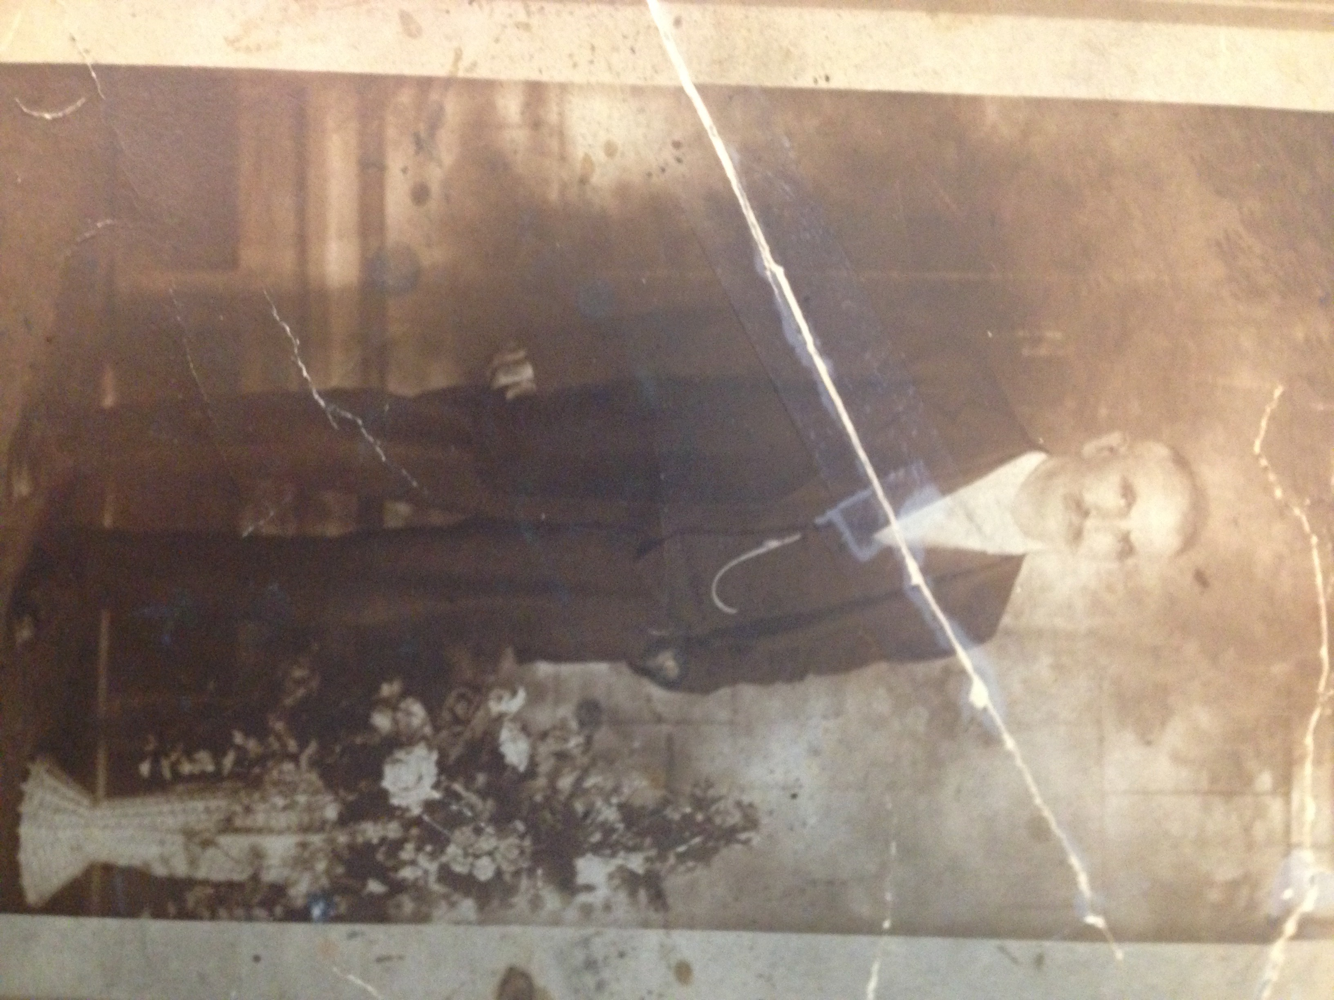
Domenico Aloia, grandfather of Mary and Sally Aloia.
Virginia Aloia, the oldest daughter of Giuseppe and Letizia Aloia, cared for younger siblings while their parents worked on the family farm in the south end of the city.

Family of Sarah Jane (Sally) Aloia (b. 9-30-1935, Washington, PA)
and Mary Elizabeth Aloia (b. 7-14-1920, Washington, PA)

Sally and Mary’s Father:
Giuseppe Aloia, b. 3-9-1891, Aquara, Province of Salerno, Naples; d. 4-1-1970

Sally and Mary’s Mother:
Letizia (Daisy) Martino Aloia, b. 9-17-1894, Bellosquardo, Province of Salerno, Naples; d. 6-3-1980, Washington, PA

Giuseppe and Letizia’s date and place of marriage:

9-24-1914, Immaculate Conception Catholic Church

Giuseppe and Letizia’s Children:
Virginia Aloia Chicora, b. 10-25-1915, Washington, PA; d. 3-1-2000, Washington, PA; m. John Chicora, children Cecelia, George, John, Paul, Judy, Mary Jane
Dominic George Aloia, b. 2-22-1918;
d. 5-25-1960
Mary Elizabeth Aloia, b. 7-14-1920
Rose Aloia, b. 3-3-1923; d. 3-14-2009; m. Warren Taylor, children Warren, Carol; m. Roy Salisbury, children Alfreda, Rose, Roy Jr.
Louise Aloia Jones, b. 9-24-1926; d. 10-31-1979; m. Frank Jones, children Bob, Frank, Kevin
Louis (Luigi) Patrick Aloia, b. 3-17-1929; m. Vernadine Davis, children LouAnn Aloia Uram, Joseph Mark Aloia

Pearl Aloia DeLuca, b. 7-25-1932; d. 11-25-2016; m. Frank DeLuca, children Lisa, Lori
Sara Jane (Sally) Aloia, b. 9-30-1935

Giuseppe’s parents:
Domenico Aloia and Virginia Marchese Aloia

Domenico and Virginia’s Children:
Giovanni (John) Aloia
Angeline Aloia DeLuca
Mary Aloia Churcio
Giuseppe Aloia, b. 1891, Aquara, Province of Salerno, Naples
Luigi Aloia
Teresa Aloia Dolciamore
Lucido Aloia

Letizia (Daisy)’s Parents:
Francesco Martino and Maria Macchiaroli Martino

Francesco and Maria’s Children:
Letizia (Daisy) Martino Aloia, b. 9-17-1894, Bellosquardo, Province of Salerno, Naples; d. 6-3-1980
Esterina Martino Aloia, m. Luigi Aloia, Washington, PA, children Benjamin, Virginia, Dominic, Frank, Joseph
Josephine Martino (was a nun in Italy)

Interview

Date, Time and Place of Interview:

March 27, 2017; 1:35 pm; 184 Rural Ave., Washington, PA

Interviewers:
Tina Calabro

Others Present:
Dyane Troiano

Transcriber:
Dyane Troiano

Summary Authors:
Dyane Troiano and Halie Tucci

Tina Calabro: Today we are interviewing Sally and Mary Aloia about their experiences as Italian Americans growing up in Washington. Mary, what is your full name?

Mary Aloia: Mary Elizabeth.

TC: Sally, your full name is?

Sally Aloia: My proper name is Sara Jane. Why they called me Sally- I don’t know.

TC: Mary, your date of birth?

MA: July 14, 1920.

TC: Where were you born?

MA: Here in Washington on Houston Street. Elaine D’Agostino Romano’s house.

SA: Elaine Romano lives there now.

TC: Sally, how about you?

SA: I was born right here in the bedroom where I sleep now. I was the only one born here. Mary, Dominic, and Rosie were born on Houston St., Virginia on lower East Prospect. Then, they came to Rural Avenue in the big house next door. That’s where Louise, Louis and Pearl were born. Then they moved here in June of 1935, and I was born in September.

TC: Are you the youngest?

SA: I’m the youngest of eight.

TC: What was your father’s name?

SA: Guiseppe (Joseph) Aloia

TC: What was his birthday?

MA: March 9, 1891

TC: Where was he born?

SA: He was born in Aquara, Province of Salerno, Naples.

TC: Then your mother?

SA: Letizia Martino Aloia, born in Bellosquardo, Province of Salerno, Naples. When she lived on Houston Street, her Irish English neighbors -- they were nice people -- but one of them said, “Mrs. Aloia, we can’t pronounce ‘Letizia.’ We’ll call you Daisy. See the flowers blooming there? That’s what they are called.”

TC: Did she go by Daisy?

MA: She went by Daisy.

TC: For the rest of her life?

SA: Yes. (Mary and Sally both laugh.)

TC: What was her birthday?

SA: September 17, 1894

TC: Where was she born?

SA: Bellosquardo, Province of Salerno, Naples

TC: Have either of you ever been married?

SA: No. We are two old maids. We baby our nieces and nephews.

TC: How many do you have?

SA: (starts counting) Eighteen. We lose count of the great and great, great nieces and nephews.
TC: That’s wonderful! What about work experience?

MA: I worked for 32 years at the George Washington Hotel as a clerk.

SA: There was a drug store there – Taylor’s Pharmacy. She worked there.

MA: I worked at the fountain. Served and everything for 32 years.

SA: But before that…

MA: I worked for six years for Presbyterian Senior Care. It was Hillsview Sanitarium then.

TC: What did you do at Hillsview?

MA: I worked in the dining room.

TC: Then to Taylor’s Pharmacy. Did you cook there?

MA: I made mostly sandwiches, and also worked at the Miscellaneous counter.

SA: Before Hillsview, she did housework for people on LeMoyne Ave.

(Train whistle can be heard in the distance.)

TC: I hear a train. Does that go by every day?

SA: Yes, but usually a little later in the day.

TC: Sally, what work did you do?

SA: I worked for Bell Telephone Co. I started there as an operator in 1953. In 1956, we went to dial. Before that, the operator would ask, “Number please?” The operator would then connect the caller to the person they were calling. When [Bell Telephone] went to dial they didn’t need as many operators in town. A good many transferred to Pittsburgh. I worked in Pittsburgh for 40 years in the engineering department Downtown on Stanwix Street. Before that, I was here on E. Beau St.

TC: What did you do in the Engineering Department?

SA: I was filing, then I was a supervisor. I retired in 1995. I was in various carpools. The last 15 years, I was fortunate enough to get in a van pool. We women didn’t have to drive. That was nice. I was once in a carpool with four men. I was the only woman, and I had to take my turn driving no matter what kind of weather it was.

TC: So how many years with Bell?

SA: 42 yrs.

TC: So now we’ll talk about your siblings. Their names, birthdates, where they were born, and their occupations.

SA: Ok. Start with Virginia. She was born October 25, 1915.

TC: Her occupation?

SA: Well, sorry to say, the older ones didn’t graduate high school. They quit and got jobs to help the family. Virginia did housework, worked at the George Washington Hotel, Hillsview Sanitarium and Duncan and Miller glass factory. Then she got married and had six children. Her husband worked at the water company.

TC: What was her married name?
SA: Chicora. Her children are Cecelia, George, Paul, John (T.T.), Judy, and Mary Jane. George now owns Kurtz Monument Company and several other monument companies in western PA.

TC: Next in line after Virginia?

SA: Dominic. He was possibly the only grandson my mother’s mom got to see (but I think our cousin Ben got to see her too). Dominic was stationed in Foggia, Italy, in World War II. On weekends, he would get a pass and visit my grandmother. He worked at Hazel Atlas before entering the service. When he returned from the service after four years, he wasn’t that well. He died at the age of 42.

Dyane Troiano: His birthdate?

MA: February 22, 1918.

TC: So he died in 1960. What about Virginia?

SA: She died March 17, 2000.

TC: You are next in line, Mary, on Houston St?

MA: Yes, on July 14, 1920.

TC: Then next?

MA: Rose was born March 3, 1923.

TC: When did she die?

MA: She died in March 14, 2009 and was buried on St. Patrick’s Day.

TC: Was Dominic married?

SA: No

TC: Was Rose married?

SA: She was married twice. She married Warren Taylor. They had two children -- Warren and Carol. Then they divorced and she married Roy Salisbury.

MA: They had three children – Alfreda, Rose and Roy Jr.

TC: Was your sister Rose born on Houston St?

MA: Yes

TC: Did she work?

MA: That was World War II. She worked at Duncan and Miller with Virginia, and after as a clerk at Nickles Bakery.

TC: Then Louise. What year was she born?

MA: 1926 on Sept. 24. Louise was born up here at 186 Rural Ave.

TC: Was she married?

SA: She married Frank Jones. They had three sons -- Frank, Bob and Kevin.

TC: When did Louise die?

SA: Oct. 31, 1979

TC: Did she work?

SA: At Duncan and Miller.

TC: Then Louis was next?

SA: Louis Patrick
TC: What year was he born?

SA: March 17, 1929, on Rural Avenue. He worked at the A&P. He married Vernadine Davis. They had two children -- Louann Uram who lives in Naples, Florida, and Joseph Mark Aloia. Joseph owns Pancake Towing. His father Lou and his son Joe Jr. are employed there. His mother Vernadine is the night dispatcher and his daughter Lauren is the day dispatcher. Joe Sr.’s son Steven works elsewhere.

MA: Pearl is next.

TC: When was she born?

MA: July 25, 1932. She passed away November, 2016. She was on dialysis for 10 years. She was born on Rural Ave. She worked at Montgomery Ward and then Bell Telephone.

TC: Was she married?

MA: Yes and had two girls -- Lori and Lisa. Pearl married Frank DeLuca.

TC: Let’s talk about your parents. Where did they meet?

SA: Dad lived on lower East Prospect and Mama’s aunt lived next door. He saw a picture of Mama and he sent for her.

TC: So your father was born in Italy and came here by himself?

SA: Yes, he came by himself then went back to Italy once after his mother died. His father and most of his siblings then came to Washington. The youngest was eight years old. My dad’s older brother, Giovanni (John) stayed and got married in Italy. Then he and his wife came over later.

TC: How old was your father when he first came over?

SA: I think he was about 15 or 16 years old.

TC: What was your dad’s father’s name?

SA: Domenico Aloia.

TC: What work did he do?

SA: When he came here, he worked for Hazel Atlas Glass Company.

TC: Did your grandfather ever remarry?

MA: No, he never did.

TC: How many children did Domenico and his wife have?

MA: Seven. Giovanni, Angeline, Papa, Mary, Luigi, Teresa, Lucido. The youngest was Lucido. He remained very close. My mother was like a mom to him.

TC: Where did the family live when they first came here?

SA: They settled on lower East Prospect.

TC: So your mom was the niece of the neighbor of the Aloia’s?

SA: My dad told [my mother’s} aunt he wanted to marry [my mother]. He sent for her. She came on a boat with her chaperone, Sabbatina Angelina, a friend from Italy.

TC: So, sight unseen, he sent for your mom? Had he heard anything about her?

SA: I would imagine so.

TC: So your mom gets here and meets her future husband. What was that like?

SA: I guess they liked each other. They agreed to marry. They were married at Immaculate Conception Church. It was located where the clock is now on campus of W&J College. Mama said the day they were married there was a funeral mass going on. They had to wait in the vestibule in the back of the church. After the funeral mass, she walked down the aisle.

MA: They were married in 1914, and Virginia was born in 1915.

TC: How much time did your parents get to know one another before marrying?

SA: A couple of months.

TC: Did your dad ever say what attracted him to your mother?

SA: She was blonde and blue eyed. I guess he fell for her. That’s our family photo on the wall.

MA: That’s my mom with the white blouse. My Mom had reddish blonde hair and blue eyes.

SA: Well, in fact, Mary, Virginia and Rose all were blonde and blue-eyed. The rest of us were darker. My pigtails were auburn. Now, here I am gray.

TC: Did your mom ever say why she liked your dad?
SA: No. She said they were so poor in Italy. She was glad to get out.

TC: Anyone else from her family come over?

SA: Yes, her sister Esterina. My father’s brother Luigi saw a picture of my Mom’s sister, Esterina, and he sent for her.

MA: So two brothers married two sisters.

TC: Was Esterina younger than your mother?

SA: Yes

MA: She had another sister, Josephine.

SA: She was a nun in Italy.

TC: Luigi and Esterina married and you had cousins?

SA: Yes, my cousin V. (Virginia). She’s 96 years old.

DT: Did Luigi and Esterina have other children?

MA: They had five – Dominic, V. (Virginia), Frankie, Benjamin and Joey.

TC: So with your Mom’s relatives and your Dad’s, it was a big family here.

SA: Dad’s sisters all moved to New York. My dad, Uncle John, and Uncle Lucido stayed here.

TC: Why did your Dad come here?

SA: It was so poor in Italy. They wanted to come for a better life. It was sad the way they lived. Worked so hard. He wanted to farm. They lived on Houston Street. They made gardens wherever there was land. Grew vegetables. Mrs. Quay lived on Elm St. She said to my father, “Pep Aloia, you want to farm? There’s a house up the hill for sale. A big field right across the road from it. Grandpap looked at the house and they moved up there. He farmed the whole area. He brought vegetables to farmer’s markets in Pittsburgh. Beautiful produce. He farmed all the way up the hill because these other houses weren’t there. My father believed that if you had a patch of land, water and sun, it was sin not to put them to use.
There was an attorney on East Maiden Street and Rural, on the corner in a big red brick house. He told my father he owned the land and the field. The attorney said if you want to farm there, you can but I want $2.00 a month. My father said sure I’ll pay you. So he paid. We later found out that man didn’t own the land. The railroad did. My father would bring him the most beautiful produce.

MA: My father didn’t speak English very well and this man took advantage of him. He saw my father didn’t understand. My father worked so hard! He raised animals here too.

SA: He had a meat route. On Friday nights, my dad and Uncle Lucido’s wife, Stella Lucern Aloia, would go to a farmer friend in Prosperity. They would slaughter and butcher the animals. Then early Saturday morning they would sell the meat to the neighbors. He did the same with the produce. What he didn’t sell my mother would can.

MA: That was the Depression. Real bad depression. Trying to raise eight kids. It made it hard on them and everyone at that time. I remember the Depression.

TC: Can you describe how poor your family was?

MA: It was very poor. Relatives lived together in one home to try to help each other. Everything we ate came from the garden. We didn’t go to the store. The only items my mother bought at the store were flour, oil, and sugar. The rest we got from the farm. The milk from the cows. We made our own butter. It was better than what you buy at the stores today. My mother made our clothing from the flour sacks. She carried sacks of flour up the hill. She lived to be 85 years old. We had no car. We walked everywhere.

SA: She had three or four cows that she milked. One cow wouldn’t let anyone but my mother touch her. My mother would have babies, stay in bed one or two days, then get up and work the garden and milk the cows. By the time I was born, things were better. My sister Pearl and I went to Washington High School. To go to school, we had 50 cents for a pass to ride to school all week.

MA: We didn’t have that. We had to walk. That’s why I quit.

SA: 1950, 51, 52, 53…we rode a streetcar.

MA: I had to walk.

SA: Pearl and I had it better than my older siblings did. They were working. Pearl got all the new clothes. I got the hand me downs. Pearl was a fun person. Very pretty girl and full of fun. One fourth of July, I had gotten a new blouse for babysitting or something. We were sitting on the front porch and Pearl was planning to go out. So I said to her, “I hope you didn’t put on my new blouse; I just got that. Please give me the thrill of wearing something new this one time.” She said, “I wouldn’t wear that; it’s ugly.” I said, “Thank God!” Then my sister Rose said to me, “Let me see your new blouse.” I went upstairs and the blouse wasn’t there!

MA: Pearl had put her old blouse on over Sally’s new one and went out!

SA: She was something! My parents were strict. We weren’t allowed out. Our windows were low to the ground and Pearl would sneak out. She would put a baby doll in bed with me so Mama would think it was Pearl in bed. At night when she came home, I’d have to let her in through my window. My mother caught on. She didn’t beat Pearl, she beat me because I didn’t tell her what Pearl was doing. (Mary and Sally laugh.)

TC: When you moved to this house, you were how old?

MA: I was 15 years old.

TC: What did you think of this new house?

MA: I cried. I didn’t like it. I missed the old house.

SA: Uncle Lucido and his family lived with my grandfather and us. It was a big house. Then, Uncle Lucido’s father-in-law gave him money to build a house across the road [on Bob Avenue]. In 1950, the railroad bought the property. They were going to tear the house down. My mother asked if they could buy it. The railroad sold it to them for $500. They moved it after building a foundation to where it is now.

MA: It took 3 days. I watched them. Our brother Louis and his family moved into that home.

TC: Was this an Italian neighborhood.?

SA: No. We were the only Italians on this hill, but down the hill there were many Italians. One day, we were talking a walk and passed a lady talking on the phone on her porch. She said, “Oh, here comes a bunch of dagos that live down the street.”

MA: Yes, she said that.

SA: My aunt, Uncle Lucido’s wife -- she was Polish -- said in Italian, “Oh what she said!” My mom and Aunt Stella worked together in the garden and doing household chores.

SA: But by the time I went to school I didn’t encounter too much discrimination.

TC: Did you, Mary?

MA: Oh yes. I remember that! A few would say, “I don’t want to be friends with Italians, they’re dark. But you, Mary, you’re fair. Why don’t you Americanize your name? You girls could get a better job.” But I would never change my name just to get a job.

SA: By the time I went to high school, things were getting better. Florence Marchione Nicolella said that Russell Marino went to Harrisburg and fought for the utilities to hire Italians. Florence was one of the first Italians hired at Bell Telephone.

TC: Talk about when the changes first came about. Do you mean electric, water and telephone companies?

SA: Yes. One of the Marino’s -- there were five brothers and one sister. Teresina was a teacher at Washington High School, Patsy was a judge. I’m not sure what the others did, but they were professional people. Russell Marino was the one who went to Harrisburg and fought for the utilities to start hiring Italians.

TC: How did you cope with it if you heard someone say something against Italians?

SA: Well, it upset you but you couldn’t say much because they were the bosses and had the authority, and Mama told us to be kind to everyone and treat everyone as you would want to be treated.

SA: Our nephew, George Chicora, got a job at the Observer Publishing Company. He was congratulated by a lot of Italians because he was the first Italian to work there.

MA: The Observer didn’t hire any Italians. He was the first.

DT: About when was that?

SA: About 1962 or 1963.

TC: All your siblings went to Washington High School?

SA: Yes, but some left school early. We are in the Washington School district. Trinity High School is closer, but we were considered within walking distance of Wash High because we lived in the city.

TC: And you had to walk?

MA: That’s the reason I didn’t graduate. All that walking! So I started working. I do all right. I get social security. I don’t make a lot but I pay my bills.

SA: And bosses me around!

TC: When your father came here, why did he choose Washington?

SA: That’s where the paisanos were. The Marino’s, Marchione’s, Macchiarole’s, Petrocelli’s, Cornetti’s, Demaria’s, Valitutti’s, Consolmagno’s…

TC: So he knew people from his hometown? Did they work at Hazel Atlas?

SA: Pretty much, or the brick yard or Kurtz Monument.

TC: All from his hometown?

SA: If not from Aquaro, it would be close by.

TC: Did they both come through Ellis Island?

SA: Yes

TC: Describe the personalities of your parents

SA: Hard working. My father was strict. He had a kind heart, but strict.

MA: Yes, he was strict.

SA: My mother would come get you at a party if you were late. If you were supposed to be home at a certain time and you weren’t home yet – yes, she would.

MA: We have Pearl’s picture here. She was beautiful.

TC: Describe your mother.

SA: She was kind and quiet. She was meek and had a good heart. She wouldn’t interrupt my dad if he was talking. He was strict with her, too.

TC: Once they came over, they knew they wouldn’t return to Italy?

SA: Yes, because they were so poor there.

TC: Did you keep in touch with anyone there?

SA: Oh yes, my mother’s mother and sister were there.

TC: Your mom didn’t get to see them again?

SA: No. Our brother Dominic was the only one they got to see. But I think possibly our cousin Benny may have gotten to see her when he was stationed in Italy.

TC: When you were growing up, did you go to Immaculate Conception Church?

SA: Oh yes.

TC: Were there a lot of Italians there?

SA: Some, but also all nationalities.

MA: I miss going to church. I need assistance in walking so I don’t get out much except for doctor appointments. A neighbor on Acre Drive brings us communion on Sundays.

TC: Who were some of your favorite priests?

SA: We liked and respected all of them. At my mother’s funeral mass, the priest, Father Ford said, “Who would have thought someone in a little village in Italy would name their daughter Joy. That’s what Letizia means in English.”

TC: How old was your dad when he died?

SA: He was 79. He had uremic poisoning. They didn't have the medicine they have now. All the poison backed up in his blood stream and it killed him.

TC: What kind of things did you do for fun while growing up?

MA: Walk up the hill. One day, the neighbor’s bulls chased us. I lost my shoe.

SA: We would go for walks, play kick ball, jacks, hide-and-seek, hop-scotch. We were always outside.

MA: Jump-rope.

MA: Every Sunday we would walk to the cemetery on Locust Avenue to visit my grandfather’s grave. That was a long walk.

TC: So you grew up with your grandfather in the same house. What was his personality like?

SA: He was a kind man but he liked to drink.

MA: Oh, he drank! He’d take a gallon of wine. He made his own wine. He had an accordion. He’d go on the back porch, drink wine and sing.

SA: Neighbors would say, “There’s Mr. Aloia.” He was kind but don’t get him mad.

TC: What about speaking Italian? Did everyone speak it at home?

MA/SA: We do speak it. The older nieces and nephews speak Italian also.

TC: Did your parents learn English?

SA: My mother could write and speak in English. She taught herself to read the newspaper. She signed our report cards. She did very well.

MA: My father spoke broken English, but could not read or write in English.

TC: Did your grandfather learn English?

MA: Yes, but he had broken English.

TC: What did they do at Hazel Atlas?

MA: They were laborers. They shoveled glass and did various factory duties.

SA: We had a lot of glass factories -- Brockway; Hazel Atlas 1, 2 and 3; Duncan and Miller; Tagert Valley; Washington Company.

TC: Did your parents read an Italian newspaper or listen to Italian radio shows?

SA: Every Sunday they listened to the Italian radio show.
TC: Tony Ortelli, my dad, listened to him. Did they belong to any Italian organizations?

SA: Mama did, the Sons and Daughters of Italy.

MA: I did too, but I can’t get out anymore to go to the meetings.

TC: Did your parents have friends who weren’t Italian?

SA: Oh yes. Several friends who were not Italian. My father used to buy his animals from farmers at auctions who were friends but not Italians. My sister Pearl was named for one of the farm ladies. When I was born, they were going to name me Ruby after friends who sold my father animals. Mary spoke up and said, “No, Sara Jane.” Thank god!

MA: Sara Jane was a friend of mine from school. So the doctor said, “What shall we name the new baby?” I was 15 years old so I said, “Sara Jane” My dad said, “Name her Sara Jane.” All the kids were born at home. In a couple days, my mother was up taking care of the animals and the garden.

TC: Did your parents become American citizens?

SA: Yes, they did.

TC: What Italian culture did they bring to the United States?

SA: The cooking traditions -- all the pizzas, biscotti, baked goods, rice pie, ricotta pie, lasagne. Gardening skills. Love of opera. And hard work! And respect for everyone!

MA: My father raised the best tomatoes.

SA: He had a fig tree in the front yard. He would ask the city to dump most of the leaves they picked up around town in the yard. He used them to bury the tree for winter. All the Italians would come up in August to get figs. Louise Merlo in her 90’s walked up the hill to get the figs.

MA: I always worked in the yard. I stopped at 95 years old, cleaning the bank over the hill.

SA: One time she got stuck down the bank. I didn’t hear her yelling. Our neighbor helped her up the bank.

MA: I’m 97 now; how much longer will I be here? I need assistance in getting dressed. I have a lady who helps me bathe.

SA: I used to bathe her until we both fell. We were stuck until my niece Cecilia Wiley came to our rescue. God bless Cecelia. She calls us twice a day. Our niece, Carol Furmanek, who lives in West Finley, calls us frequently also.

TC: Any other story about growing up before we finish?

MA: I still sing the old songs in the mornings.

SA: She brushes her teeth and sings.

MA: My brother Dominic used to sing all the Italian songs. He had a beautiful voice. Mom used to sing, “O Solo Mio.”

SA: Once, my mother and I were at the doctor’s office in the waiting room and she started to sing (she was getting a little dementia). I told her “shhh,” and an Italian man sitting there said, “Let her sing. If these people don't like it, the heck with them.”

TC: Final words?
SA: We miss our parents, brothers and sisters, and other family members who are gone. All in all, we had a good family and a good life. And we hope our nieces and nephews keep our family traditions alive.

