Silvio Passalacqua
Son of Angelo Passalacqua and Giacomina (Jenny) Cirelingione

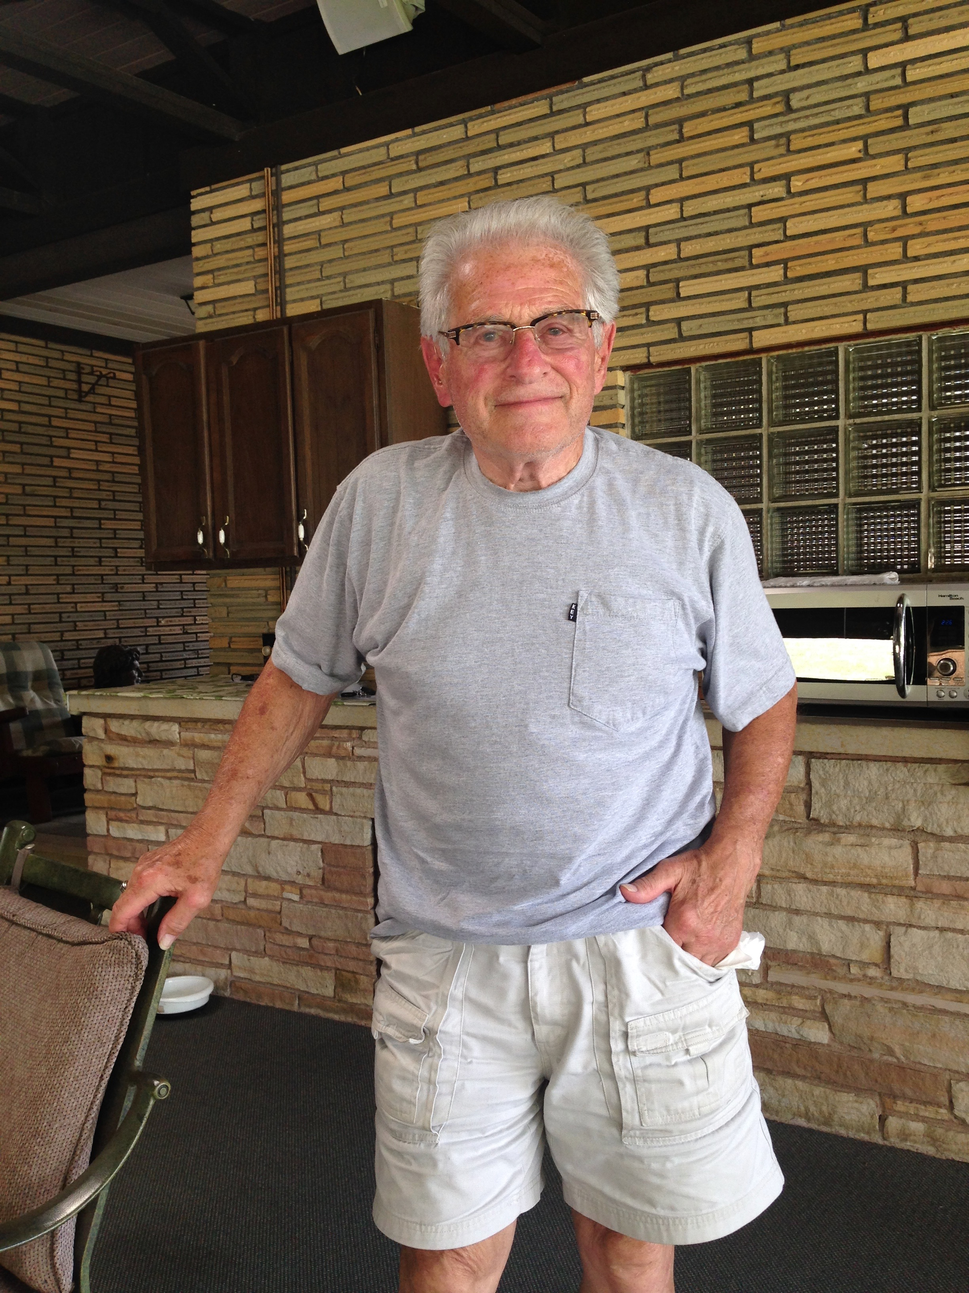

This is an interview with Silvio Passalacqua, youngest son of Giacomina Cirelingione (b. 1898, Villa Rosa, Sicily) and Angelo Passalacqua (b. 1888, Messina, Sicily), who established one of Washington’s most enduring Italian restaurants. The restaurant, originally called West Chestnut Spaghetti Inn and located in the West End, was renamed “Angelo’s” after the owner’s death in 1952. Today, the restaurant remains in family hands in a new location on North Franklin Drive, with Silvio’s son, Michael Passalacqua, as owner.

In the mid-1930s, Angelo traveled back and forth from Pittsburgh (home to his wife Giacomina’s family) while setting up his first tavern on Wylie Avenue in Washington. Once he was assured of its success, he moved his wife and five children to town. He founded West Chestnut Spaghetti House with business partner Matt Randazzo in the early 1940s and moved to quarters above the restaurant. To this day, the home cooking of Silvio’s late mother Giacomina – especially her lasagna – continue to inspire the menu at Angelo’s.

Silvio, now retired and serving as a supervisor for North Franklin Township, recalls his parents’ ceaseless dedication and work ethic. In his interview, Silvio reflects on the family’s 80-year history in the restaurant business, the lessons it has brought, and the inevitable changes that occur in any such enterprise. His reflections are replete with humor, humility and love of life.

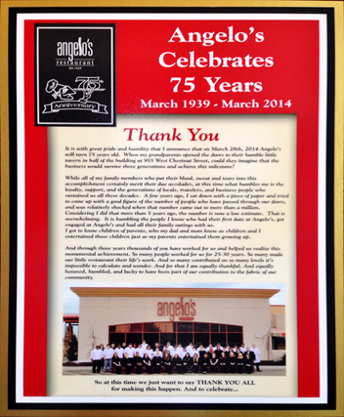
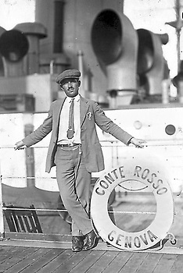
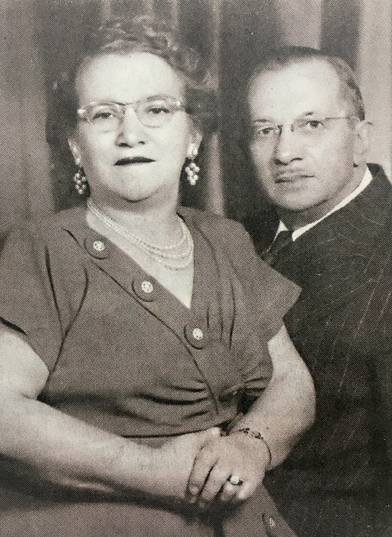
Giacomina and Angelo Passalacqua Angelo Passalacqua

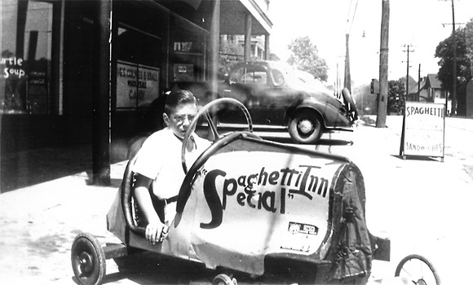

Angelo Passalacqua

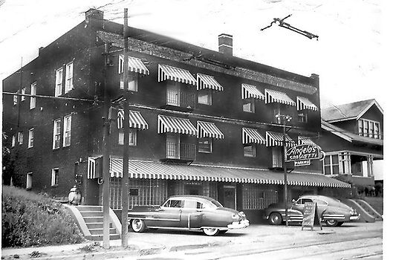
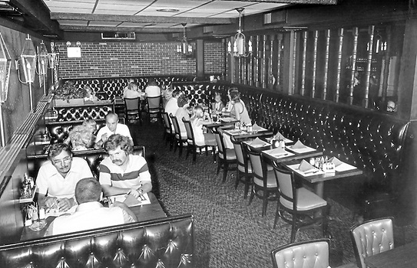

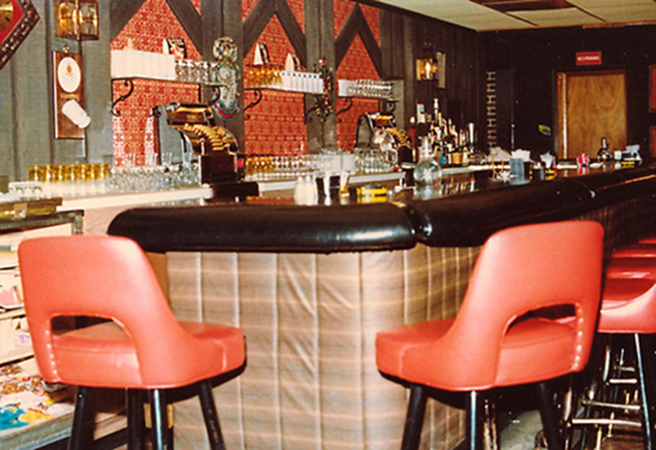
Angelo’s Restaurant

Family of Silvio Passalacqua (b. 6-15-1930, Pittsburgh, PA)

Silvio’s Father:
Angelo Passalacqua, b. 1888, Messina, Sicily; d. 1952, Washington, PA

Silvio’s Mother:
Giacomina (Jenny) Cirelingione, b. 1898, Villa Rosa, Sicily; d. 1970, Washington, PA

Angelo and Giacomina’s place of marriage:
Pittsburgh, PA

Angelo and Giacomina’s Children:
Mary Rose Gerolium, b. 1920; d.; graduated from Oliver High School, Pittsburgh
Josephine, d. age 10
Carmellina Passalacqua Di Stefano
Antoinette Passalacqua Belcastro
James Passalacqua, b. 1924
Anthony, d. in infancy
Another brother d. in infancy
Silvio, b. 1930

Angelo’s Siblings:
Salvatore, b. Messina, Italy; d. Italy
Carmelo, b. Messina, Italy; m. Josephine; had a bar and restaurant in Washington; had two sons Salvatore (Sam) (died in Luzon, Philippines, in WWII) and Carmelo Jr. (m. “Cookie”)
Sebastiano, b. Messina, Italy; d. Italy
Mateo, b. Messina, Italy; m. Rose; had a bar (Venetian Gardens) in Canonsburg; had two daughters, Mary (m. Leroy Verna, who

owned Leroy’s Music Mart in Canonsburg) and Carmella (Sis) (m. Patsy Pitzerella)

Giacomina’s Siblings:
Angelo Cirelingione
Sam Cirelingione, had a barber shop
Rose Cirelingione Solima

Silvio’s Spouse:
Patricia Hixon Passalacqua, b. 3-30-1930, Burgettstown, PA; d. 2007, Washington, PA

Silvio and Patricia’s date and place of marriage:
7-1-1951, St. Hilary Catholic Church, Washington, PA

Silvio and Patricia’s Children:
Michael, b. 1955, Washington, PA
Michele, b. 1955, Washington, PA
Toni Ann (Tonne), b. 1958, Washington, PA

Silvio’s Military Service:
Army Reserves

Silvio’s Occupation:
Owner, Angelo’s Restaurant, Washington, PA

Interview

Date, Time and Place of Interview:

March 9, 2017; 11:00 am; Citizens Library, Washington, PA

Interviewers:
Sandy Mansmann and Tina Calabro

Transcriber:
Liz Terek

Editor:
Tina Calabro

Sandy Mansmann: Where were you born?

Silvio Passalacqua: Pittsburgh. I went to first grade in Pittsburgh. I went to Horace Mann school and then we moved to Washington.

SM: And your mom’s name?

SP: Giacomina! You know, I got a history, a lesson from an Irishman one day. I was buying an insurance policy one day and I spelled my mother’s name with an ‘o’ on the end of it. He said, ‘No, no, no. ‘O’ is masculine and ‘A’ is feminine.’ I got a lesson. (laughs)

SM: And your children?

SP: Yes. I have twins -- Michael and Michele. And the youngest is Tonne. T-O-N-N-E, she goes by. She don’t like the Toni Ann any more.

SM: And your spouse?

SP: Passed away 20 years ago, in ‘97. Patricia. Her maiden name is Hixon.

SM: That doesn’t sound very Italian.

SP: She’s not. I made her Italian (laughs). I converted her.

SM: (laughs) And her birth date?

SP: March 30th. And she’s 1930. We were both to the same age.

SM: And her birth place?

SP: I guess Burgettstown. That’s where she was from.

SM: Did she work outside of the home?

SP: When we were first married, she had a couple secretarial jobs. But after that, we got into the business with my dad and then, after my dad passed away, we ran it for my mother. Then me and my sister took it over. Then, later on, I bought my sister out.

SM: So, this is, what’s your business?

SP: Angelo’s Restaurant!

SM: Okay, so you are still currently involved down there?

SP: No, no. My son Michael has it. I’m out to pasture.

SM: (laughs) So, how long were you involved in the whole process of establishing it? Running it?

SP: Since I was 20 years old.

Tina Calabro: Before you were married?

SP: Yes. Want to know how I met my wife?

SM: Good food?

SP: No. I was a singer in the Johnny Cimino Orchestra. We played at the Alpine Club all the time. There were four girls sitting at a table. I told a friend of mine, I said, ‘Hey! That girl over there with the sharp legs sticking out, ask her if she’ll marry me.’ That was the beginning.

SM: What was the name of the place?

SP: Alpine Club. It was the Italian Club.

SM: You were with what group?

SP: The Johnny Cimino Orchestra. Eleven piece orchestra.

SM: Singer or what instrument?

SP: Yes, like Sinatra, Tony Bennett, them type tunes.

SM: So you were the star singer?

SP: I was a pretty big fish in a little pond, yeah.

SM: (laughs) How long did you court before you actually got married?

SP: Court my wife? About a couple years. Only a couple years.

SM: So, your son Michael now runs…

SP: Sole owner. Yes.

SM: Were you involved in any other occupation before the restaurant?

SP: No.

SM: You didn’t shine shoes or….?

SP: No, not yet.

SM: (laughs) Something to look forward to, huh?

SP: (laughs) Yeah.

SM: Did you serve in the military?

SP: I was in the organized Reserve for 6 years. That was during the Korean War. We got alerted for activation twice, but never got the call.

SM: Where were the Reserves based out of?

SP: Well, we met on Chestnut Street where old Newmark Shoe Store used to be. That was the meeting place. We met there once a month. Then we went to camp for two weeks every year. Different forts. Fort Meade. Fort Eustis, Virginia.

SM: Meade in Maryland?

SP: Fort Meade in Maryland.

SM: Fort Eustis in Virginia down by the ocean?

SP: Yeah. And Fort Eustis that was in Virginia. There’s another one I can’t recall. (Later remembered “Camp Pickett, VA”)

SM: Now, we’re going to go back to your family, your birth family. Your siblings’ names.

SP: My oldest sister was named Mary Rose. Second in command was a daughter, Josephine, who was killed coming home from school by a car. I never met her. Because I’m the youngest, I never knew her.

SM: I should ask you, how many children [in your birth family]?

SP: Five now. There was eight. I had two infant brothers, when they lived in Boswell. They died in infancy. And my sister, Josephine was buried, or entombed over in Pittsburgh Catholic Cemetery where my mother and father are.

SM: What cemetery?

SP: North Side Catholic. Boy, I’m surprised I remember half this stuff. I ain’t too good at that usually.

SM: Josephine was killed by a car on the way home from school.

SP: Yes, yes. Hit, hit...

SM: Elementary school or…

SP: Yeah. Yeah, she was young. She was about 10, I think. Roughly.
SM: Okay then, onto the next, your third….

SP: The next one is Carmellina.

SM: (extended enunciation) Carmellina. We got some girls goin’ on here.

SM: Is Mary Rose still living now?

SP: No. I don’t know who is the older between my brother, my sister and I. It was a year apart or something. Antoinette and then, James. James is the only one, we’re the only ones living. The three girls are gone.

SM: So are you number six?

SP: Yeah.

SM: And the youngest [alive]?

SP: I’m the youngest.

SM: So, the two boys that died in infancy?

SP: I think that’s when we lived in either Somerset or Boswell. I think that’s where they first came, when they came [to the U.S.] and then they migrated to Pittsburgh.

SM: They were so young, were they named at all? Or they didn’t live that long? The two boys?

SP: Yeah, one of them was Anthony and I don’t know what the other one was.
They died of rickets. I don’t know what rickets is. It’s a deficiency in sunlight or something else. I don’t know.

SM: Did any of your siblings remain in Washington?

SP: Yeah, they all did. They never left town.

SM: Is there anybody in the family that is a family historian?

SP: Well, maybe Michael knows more about it than anybody else.

SM: Do you have any idea how your mom and dad met?

SP: I think my dad came to the United States first and then my mother came second. Then, my Uncle Sam, who is my mother’s brother, got the two of them together. That’s Sam Cirelingione.

SP: I think my Uncle Sam brought them over. I know he used to have a barber shop and he used to brag, ‘I brought your mother over here on 50 cents a haircut.’ So how they did that, I don’t know. (laughs)

TC: Where was his barber shop?

SP: In Pittsburgh, down on Beaver Avenue (North Side). When they got flooded down there, they come up and lived with us on Superior Ave. Up on the hill.

TC: So you lived on Superior? Is that considered Troy Hill, or is it just up the hill from the North Side?

SP: Uh, I don’t know. It’s 1256 Superior Ave.

SP: You know, for all the years I was going over to the cemetery for my mom and dad, it took me, I don’t know how many years to find that house again. But, I was just a little kid. I remember a lot about it.

SM: Is it still standing?

SP: Yeah. Well, it’s been like six, seven years ago. But, I’m sure it’s still there. It was a good house. A good neighborhood. My sister Mary graduated from Oliver High School. My other two sisters and brother, I think they started there. But, they didn’t finish their education until we moved to Washington.

SM: Once they got to Washington, where did they go to school?

SP: Wash High. Washington High School. I went to 7th Ward when we lived there. Then we moved to Tylerdale. I went to Clark School. Then, when we moved out Chestnut Street, I went to 8th Ward School. And from there, if you pass all your grades you get to go to Wash High.

SM: If you pass. Did you pass all your grades?

SP: I did okay. I could’ve done better if I’d applied myself, but I was into jitterbugging and, you know, stuff like that.

SM: You had other things to do.

SP: Yeah. Priorities.

SM: Did you graduate from Wash High?

SP: Yes. 1947.

SM: Anything after that as far as [formal education]?

SP: No.

SM: Just the education of life.

SP: Music and that’s it.

SM: Did your mother have a nickname?

SP: Jenny. J-E-N-N-Y

SM: So, the first to come from Italy….

SP: Was my dad.

SM: And then, your mom, shortly after that. But, they didn’t know each other.

SP: No, uh uh, no. My mother was from a different village and she was ten years younger. I think. Nine or ten. He liked them young broads. (laughter) It’s like me and Lois [girlfriend]. She’s nine years younger then me. I told her I need somebody to push me around in the wheelchair. I told her, ‘Lois, you stay nice and fit.’ You got to take care of me.

SM: Do you have any idea how [or why] your parents came to the US or how they heard about it?

SP: Because the streets were lined with gold. You know, for opportunity. They knew there was good opportunity here. My dad worked in one of the mills. Also, when he came over, Michael can tell you this, the boat, he worked his way over.

SM: On the boat?

SM: Yes, on the ship. He, I don’t know what his position was, whether he was shoveling coal or what, but he, he did something to earn his fare to come to the United States.

SM: I know some traditions were that they were hired here or promised work for like three years and then they would get the passage. Paid through servitude sort of.

SP: I don’t know how they ever managed that stuff. I went to Ellis Island one time. And you see people with little kids and couldn’t speak the language probably didn’t have five bucks in their pocket. Just wonder how they survived, but they managed.

SM: I guess what they were leaving must have been pretty…

SP: Sure. Pull up roots.

SM: Did your Dad know anybody here?

SP: You know, I don’t know. I can’t tell you. My mother had two brothers that lived here in Pittsburgh and one sister.

SM: What were their names?

SP: Angelo Cirelingione and Sam Cirelingione.

SM: What about the sister?

SP: Rose Cirelingione.

SM: So your mother’s three siblings, they already came here and they wanted to get her over here.

SP: I don’t know if they was here ahead of her or not. If my sister Mary was here, she could tell you about all the history. She knows everybody’s birthday and who’s what, you know?

TC: Does she have children who kept a history for her?

SP: No, she only has one son alive. He lives in Florida. He’s out of the realm, you know.

SP: My Uncle Sam was on Beaver Ave, and so was my Uncle Angelo. He had a beer distributor down there. I remember.

SM: Now, other than your dad working his way over on the ship, he came through Ellis Island?

SP: Yes, Yes.

SM: And then, what was his route, basically? Did he come strictly to Pittsburgh?

SP: You know, I have no idea. I think they first ended up either in Boswell or Somerset.

SP: Did you want to know my dad’s brothers? He had a brother, Carmello, and another brother, Sebastian. Don’t put this down, but he got deported. (laughter)

SM: Just two brothers. So, the one, Sebastian, came and went back. What about Carmello, did he come here?

SP: Yeah, he came here. He had a little bar and restaurant for a long time. Then, he moved to Florida.

SM: Where did he have his bar and restaurant?

SP: Right on Chestnut Street.

SM: What was it called?

SP: Beats the heck out of, I don’t remember. You’re too young. You don’t remember Andy Brothers Tire Shop. There were a couple doors up from there. My dad had another brother, too. Matt. Mateo. He had a bar in Canonsburg right on Pike Street. Venetian Gardens.

SM: Lotta bars in that family.

SP: Yep.

SM: So, you grew up with a lot of your Italian family here.

SP: Oh, yeah. I was only 7 years old and my dad had a bar here in Washington- with another guy. He used to sleep in the back room. In those days, he was down on Wylie Ave. It was a very tough spot. Half of it was black. Half of it was white. More than once there were collisions there. He used to come home [to Pittsburgh] on Saturday night after he closed. You weren’t allowed to be open on Sundays then. He stayed home until Monday morning and he drove back.

SM: To Wylie Ave? In Washington?

SP: Yeah. Then my father told my mother, if she didn’t come to Washington with him, then he wasn’t coming home no more. That was a tough trip.

SM: So he lived in Pittsburgh?

SP: That’s where the home was. Yeah. He just had a little cot in the back room of the bar. Shortly after he got outta there and started on West Chestnut Street with his brother Carmello, there was a double killing in there. Somebody killed somebody and then they come back to the bar after the owner and the owner shot him. So, two guys got checked off.

SM: So he owned the bar on Wylie Avenue before he moved his location to West Chestnut?

SP: Yeah. You don’t have to put that killing in there.

SM: Do you remember the name of the bar he had on Wylie?

SP: No.

SM: When he opened the restaurant on West Chestnut, was it called Angelo’s originally?

SP: West Chestnut Spaghetti Inn. With Matt Randazzo as partner.

SM: Do you remember what year he founded that restaurant?

SP: No. I have no idea. Yeah, my dad got outta there just in time. Ran a good business out in West End. We started out as just a little tavern and had half of that building and when he bought the building, we took the whole downstairs. There were four 6-room apartments upstairs. How did my dad ever do it? He was a good businessman. He couldn’t read or write that much in English. But he knew how to make the bucks work.

SM: So once they got here, I guess they stayed.

SP: Yeah. Wait a minute, my father had another brother who stayed in Italy and never came here. He was a policeman. What the hell was his name? ‘Cause I remember my dad sitting in a chair, big tears coming out of his eyes and he had this letter in his hand, with a black thing all the way around it, telling him that his brother died. Man, I can’t think of his name.

SM: He just died of natural causes?

SP: I guess, yeah.

SM: It wasn’t in the war or…

SP: It might’ve been Salvatore, but I’m not sure.

SM: Did you or did anyone in the family keep in contact with relatives in Italy?

SP: My dad did. They corresponded back and forth. My dad and his brother. Very little, but they did touch bases. One knew where the other one was. And that was about it there.

SM: What about your mother? Did she keep in touch with her parents over there?

SP: They came here ‘cause they’re both buried up in North Side Catholic- her mother and her dad. My grandmother lived with us for awhile. Still had the black dress and the black stockings. I had to go to the store with her when she’d buy sliced bread and I was just a little kid. But I’d get so embarrassed. She’d chisel that guy for a loaf of bread. She didn’t want to pay regular price. (laughter)

TC: Do you remember the first names of your mother’s parents?

SP: No.

TC: But they lived with you?

SP: No, just the mother.

TC: The dad died?

SP: Yeah, I guess he died first and then, she lived with us for a while. But back in them days, somebody died, you put them black clothes on and….

SM: And it’s your mother’s parents that are buried in North Side?

SP: Yes, yes. Right. My dad’s brother [Carmello] and his wife [Josephine] are buried in North Side Cemetery, and also their son [Sam], who was a paratrooper and got killed in the Second World War. He was a paratrooper.

TC: And his wife? They’re all buried in North Side?

SP: Yeah. Right.

SM: The neighborhood, where you lived here…

SP: Well, we lived on Jefferson Ave. Right next door was either a dairy or a bakery. I don’t remember much about any activities there. Other than going to school there. I remember, as a kid, I used to wait for my dad to come home from deer hunting so I could carry the rifle in the house and hope somebody could see me, you know? (laughter)

SM: Where on Jefferson Ave. would that be? What’s there now?

SP: In between Chestnut Street and that little Henderson Ave. No, not Henderson! What’s the one the goes alongside Wash High?

SM: Hallam?

SP: Hallam! Yeah. Lower, closer to the bottom of that.

TC: You were seven when you moved here?

SP: Probably. Yeah ‘cause I went to second grade here. I might have been 8, I don’t know.

SM: Approximately how long or until what grade were you at that location?

SP: Well, my last stop was 8th grade at 8th Ward School. Then I went to Wash High, so I’d a been….

SM: Well, you were at Jefferson, do you remember how many years approximately?

SP: Maybe two.

SM: What was the next one?

SP: Tylerdale down at Clark School. On Allison Ave.

SM: How long were you on Allison Ave.?

SP: From there I went to, well, I was in 4th grade at 8th Ward, so a couple years that’s it.

SM: That’s when you went to Clark?

SP: Yeah.

SM: Then, where did we go after that?

SP: After Clark? To 8th Ward.

SM: What home? Did you change homes?

SP: Yeah. We lived on the corner of Hayes Avenue and Chestnut Street.

SM: In the homes that you lived in, were your neighbors predominantly Italian or not?

SP: No, nothing like that. I think it was where my dad could do the rent. But, these were always nice places. We didn’t live in any bad conditions. He was a good provider.

SM: So, you were basically in a mixed neighborhood.

SP: Yeah, yeah.

SM: As far as a community, what were your ties? Were Italians necessarily in the same church or organizations? Fraternal organizations or social?

SP: Well, I went to I.C. [Immaculate Conception] Church. Although I was married in St. Hilary because my mother talked to the priest down there, to do it on Sunday. All my relatives were in the bar business. Nobody thought you could close a day to go to a wedding. I remember Father Zapora was his name. I remember after the wedding was over, taking pictures and he told my mother, ‘Get these people the hell outta here! The pope’s going to find out about it!’ (laughs)

SP: But my daughter, both my daughters, got married at Immaculate Conception [Church]. My son waited until he was 62 before he got married. He needed to make sure. (laughter)

SP: My daughter, Tonne, I sent her to Hyde Park, to a culinary institute. She went to Colorado after that. Well, she met a guy and he was a good skier and she was a good skier. She turned our business around from the tavern, too. A better restaurant, yeah.

SP: She was working with University of Colorado Springs. She was in charge of the food service for about four or five different entities in there. But she said she just couldn’t stand the kids anymore. They wouldn’t work. They all had bad attitudes. They call off. She said, ‘Dad, I used to throw up before I went to work’. So, now she’s working for a different company. She’s on the road again. Because she worked for US Foods and Sysco and that was her bag. Out there, it’s very laid back. You can take your dog with you when you’re going to work. (laughter) You go into a restaurant to eat and the guy at the cash register, his dog might be laying there. Which is ok!

SM: From Hayes, the corner of Hayes and Chestnut, is that where you stayed?

SP: Yeah, the family stayed there. My dad died after my mom died. Then my sister took over the house.

SM: The family still owns that property?

SP: Yes, my one sister [Carmellina], who died. Her husband has [the property].

SM: Ok, so where did you go from there?

SP: I went to Washington, D.C. for a while. I worked for the F.B.I. I was a clerk typist. When I got it in the mail, it said Miss Silvio Passalacqua. Clerk typist. They were interviewing down at Wash High.

SM: Did they ask if you wore high heels?

SP: Well, no, I went down there. I looked around and said I don’t know how to type and I ain’t a girl, so I sneaked around and saw some guy was in there. You had to get cleared pretty good for that. That’s when Communism first raised its head and they were, it was a File 67. They were investigating everyone who had a government connection. Army, Navy, Marines, government workers to see if they had any affiliation with any. You had to search their files for ten years for friends, cousins, uncles -- anybody that was connected with them, and see if you got a number from a file. Go to the General Index and look them up. Three of the guys I lived with became F.B.I. agents. Back then, you just had to have four years of accounting. Or four years of pre-law. Now, you have to pass a bar and all that stuff. But they was going to night school while we all lived together. It was five of us living in a big house we rented. A furnished house.

SM: Do you remember where your house was?

SP: It was Southside, in a nice neighborhood. We took the bus to work everyday. Down on Constitution Ave. The J. Edgar Hoover Building. I lived on Georgia Ave. with relations when I first got there.

SM: So your stint in D.C., how long do you think you were there?

SP: I was there for about three years, I think. I got homesick and come home. I had a girlfriend here. After coming home from Washington, D.C., I worked at a gas station. I had a construction job with Iron Workers. I drove a beer truck. And when my boss dropped dead, I went to work for my dad. I was only 20 years old at the time. You had to be 21, really. You had to be 21 to drive a beer truck. I squeezed in there.

SM: How come with such an Italian family you had so many people in beer?

SP: Well, dad knew Patsy Verano, the guy who owned the place and he got me the job. The good job I had was with Johns Mansville Construction Company. I was making a buck and a half an hour. We were working five days, ten hours and the other two hours were time and a half. I was making more money than my brother-in-law. He had a couple kids. I used to wave my check at him. That was a big bunch of change there. I used to carry them big sheets of steel on my back. They was ten foot long. Then we took them over, hooked them up, and pulled them up to these guys on a scaffold up there.

SM: They maybe get caught in the wind?

SP: No, no. I was up there. We worked at J & L Steel. I worked underneath the roof with the buck up. I had to walk a little bit of steel there. But I thought I was tough. When I used to drive a beer truck, I used to go through downtown Pittsburgh with a cigarette in my mouth, sleeves rolled up, arm out with that big auto car. (laughter)

SM: You went to work for your dad at his restaurant which was then called what?

SP: After my boss at the beer distributor died, then right away they had to make some changes. So all them other distributors were like vultures and he was hooked up with somebody else in Canonsburg. I got ousted. That’s when my dad took me in.

SM: At that point what was the restaurant called?

SP: Just West Chestnut Spaghetti Inn. Just a shot and a beer place. I know a shot of wine was 20 cents. There was a lot of winos around that time. All local people. We never developed into a restaurant until Wheeling Downs opened and we had bumper-to-bumper traffic going by. Going and coming. We didn’t know what the hell we were doin’ in there. I remember my dad when somebody wanted a martini, he served it in a beer glass. They’re probably still talking about that. (laughter) But that’s when we started makin’ some money.

SM: Is the house still there?

SP: Yes. It’s a big, two-story house. Living room, dining room and big kitchen. Basement. An upstairs with all the bedrooms and the bathroom. Big yard. Big bank to cut. To mow.

SM: Did it have a Chestnut Street address?

SP: 1005. The restaurant, the old bar was 955. It was West Chestnut Spaghetti Inn down stairs. Then it became Angelo’s after my dad died. Well, we had to get the name registered under a fictitious name and it became Angelo’s.

SM: Now, when you were growing up, your neighborhood, your activities, what did you do at home? What’d you do for fun?

SP: Well, in them days, people swept their sidewalks. West End was a good place. It’s bad now. The people next door, Eddie Cahill, and the guy the next street up, next house up was Bob West. He was a very good friend of mine. His uncle, Jim, had his little grocery store there. Every once in a while he’d get somebody to take groceries to some house, you know. You’d get a nickel. We’d all want to go to Mrs. Burris ‘cause she was good for a dime. It was just down a couple doors, you know? But, we lived up there and we played there. Got the police after us a couple times at night. Making noise, that’s all. Running on people’s porches. Stuff like that. I remember one time, in this one guy’s yard, he had a whole bunch of corrugated sheets stacked up, but there were only two skids [to keep the sheets off the ground]. There was a little dip there [and] I could fit in that space. When somebody would call the police on us, I would stand on the sidewalk by that house. The policeman, Honey Harris or Norty Wright, would say, ‘Don’t you run.’ I’d wait until they were almost there and I’d go behind that house and dive in that thing. They’d come in and wonder where the hell I went. (laughter) Their legs would stick out. I wanted to reach out and grab their legs. I never got caught. I only got caught once. One time, me and Eddie Cahill got caught and the police took us up and said ‘We’re taking you to Morganza (reform school).’ Boy, you never heard anybody cry so loud in your life. When they got down to the bottom of Chestnut Street, they said, ‘You gonna behave?’ We said, ‘Yeah! Yeah!’ (laughter) They turned around and took us back. Scared the heck outta us in the meantime.

SM: I think Morganza was the threat.

SP: That was the reform school, yeah. We heard they beat ‘em down there and wouldn’t feed ‘em and you heard all kinds of stories. Oh, we was definitely afraid of that.

SM: You said every Sunday was a feast. Did you say you got in trouble if you didn’t show up?

SP: Oh, yeah, after my dad died, if we missed a Sunday, you got scorned a little bit. (laughter) She [my mother] kept the family together. After she passed away, everybody seemed to go their own way. I was closer with my brother and my oldest sister than anybody. I was in partnership with my older sister, Carmellina. Partnerships are no good. Especially if they’re family. ‘I did more than you.’ ‘I was here earlier.’ So, I bought them out and it was all agreeable and stuff. They were older than me anyway. They wanted to retire.

TC: How would you describe your mother’s personality?

SP: Good. She was a pleasant woman. I know one thing: If we got in trouble with Dad, she stuck up for us.

TC: What about your dad? How would you describe his personality?

SP: He was a straight, steady guy. He’d torture you to death. If you did something wrong, he’d say,’I want to see you when I get home.’

SM: You’d live in fear all day.

SP: Oh, yeah. You’d sweat. Wondering what was gonna happen. My brother, before he went to the Navy, drove my dad’s car and he had a key. When he went to the Navy, I found that key and I knew how to let clutch out and give it a gas. That’s when you had four on the floor. At night when my dad would be at the restaurant, I used to back that big Buick out of the garage, make a real sharp turn up Hayes Avenue, fill it up with guys and we’d drive all over town in low gear ‘cause I didn’t know you had to shift. I never had a wreck or anything. I was crazy. If my dad would’ve caught me, I’d have gotten killed for sure!

SM: Did your parents speak Italian in the home?

SP: Yeah. They’re not like the Greeks. The Greeks teach you, you know? But that was secret stuff. They talked Italian. My sister, Mary, could talk it the best. Then before I went to Italy, I took Italian with Theresa Cavotti for a couple years. I got pretty good. Now, I forgot all that stuff ‘cause I don’t use it.

TC: Did they both speak English well?

SP: Oh yeah, with an accent. Broken a little bit. The Sicilian accent was altogether different. Somebody told me once that they wanted their own language. When a guy came, trying to sell a sweeper to my mother, he says (formally), “Signora, questa qui.” I’d [say to myself], ‘That guy don’t know [Italian].’ My mother [explained], ‘No, that’s the King’s English of Italian.’ That’s the way you talk. We had like a slang version.

SM: What about the camaraderie among Italians? When you were growing up?

SP: I hate to say this, but Italians are not good at camaraderie. (laughter) If you got 50 cents more than me I’m jealous of you and I want to try to get 50 cents more than you. That’s like when we first went into business, you know, I don’t remember any Italians coming in there. Like the Greeks. They support one another. They teach them the language. They teach how to dance and the customs and things like that. But the Italians, it’s a shame to say, but it’s true.

SM: Sometimes, because your families are so big, you already have a self-contained community.

SP: I remember when my mother used to make homemade pasta. She’d roll that dough out. She made a pasta called like perchitelli. She’d roll big strings of pasta and in a diameter like this (gestures). She’d cut a little piece like that. She had a wire. She’d roll that thing out to a pasta string. Man, it was the best. It was heavy. You couldn’t go swimming for a couple days after that. It used to make me mad when we had company [and she’d serve this pasta]. I’d say, “Put that away and get the Vimco (store brand).” [There was only so much to go around and we wanted it for ourselves.]

TC: Did your mother do all the cooking?

SP: Oh, yeah.

TC: Did your father do any?

SP: Men didn’t do that stuff. They didn’t wash dishes. I’ll tell you a little story about my father. He didn’t drink, but he’d bring a couple bottles of beer home and at dinner time they’d drink a bottle of Fort Pitt. They had all them empty bottles there. Back at that time, there was a two cent deposit on them bottles. So I instead of taking them back to the restaurant, I had a friend take them. He’d get maybe 8 or 9 cents for them. Then we’d go straight up to Marchese’s store and get a Pepsi cola and a big candy bar. That was living. I was hijacking my dad. (laughter) My first crime spree.

TC: Did your mother have any specialties that she made that you put into the restaurant?

SP: Lasagna. That’s what started us. With ricotta. Yeah, that was a start and we went from there. Just got a little bit better. Always trying to get a little upscale. There for a while we had a nice dining room trade and in the bar I had all them truck drivers and they’d fight every once in a while. Then, finally, we got rid of all the bad people and started going the right direction. But way back then, it was like a steam table. We prepared stuff ahead of time and when my daughter, Tonne, came to work with us, she worked with a chef in Pittsburgh, and when she came to work with us, she made everything to order. Everything was sauteed. Nothing was prepared ahead of time. Then we started to develop. Then, the guy that she worked with over in Pittsburgh, a guy named Mark Cardemone Rainer, he was good. I got him to come here. He changed our restaurant all the way around. He taught us the restaurant business. We were in the tavern business. He taught us the restaurant business. I’ll tell you about him. His dad was a doctor and his sister an artist of some renown. She was a sculptor and he was a rebel. He went to Hawaii and lived on the beach with a bandanna on his head. Then he finally came home. Somehow or another he got a job in a restaurant cooking and baking. He could do anything. After he left us, he went into business with some in-laws. It was over in Southside, in Pittsburgh, and he did very well. He got all kinds of accolades and stuff. Then, the sides didn’t [get along] so he got out of that. He got into the computer business. Then, from there, he went to school and became a doctor.

SP: We used have these wine guys come in and give a demo on these fancy wines and stuff. Mark knew more about the wines than they did. He could bake. He was a baker. He was good. Fact is, I had to buy him a truck to get back and forth to work. He was leaving his wife isolated over in Whitehall. He said, ‘I’m going to have to leave.’ I said, ‘No you’re not’. I went and got a pickup truck.

TC: When you started to work in the restaurant, you worked there from the time you were 20? Was there a certain point you retired or you just kind of tapered off?

SP: No, I didn’t til way after I got the kids in the business. I think my sister and I were there about six years, if that, but I’m not sure.

TC: Did your family have any Italian traditions that you followed?

SP: Yes. Christmas and stuff like that. Christmas Eve was always the Seven Fishes or whatever that is. A big coil of hot sausage. She put the whole coil in there at once. We always had a roast and pasta on Sunday. The roast was always left over but the pasta wasn’t. Especially when she made the homemade stuff. She made gnocchi and cavatelli one time, couple times. She taught my wife how to make the gnocchi. We cooked them for an hour before they got soft. (laughs) She did something wrong with them. But I ate them anyway. There again, I couldn’t go swimming for a week. It was like lead.

SM: So you said roast, pasta, hard-boiled eggs and tomato sauce.

SP: Yeah. I’ll tell you another thing. My mother, when she was making sauce in the morning, I’d come downstairs, she’d take some of the sauce that wasn’t quite done yet, put it in a big, black skillet, cracked a couple eggs in it, poached them in the sauce, big hunk of Italian bread in the oven. All that stuff was so simple. I remember a big dessert for us. This happened when we lived in Pittsburgh. My mother would bake bread and when they come out of the oven hot, she’d bust it in pieces and we’d pour olive oil on it and black pepper. I ain’t ate it since. That was a delicacy. We all looked forward to it. It was good virgin olive oil on it. I don’t know why the black pepper. But, it wasn’t hot. You know? It was good.

TC: As a final question, what did growing up Italian mean to you? As a young person, as a child, what did it mean to you?

SP: Well, I don’t know if I was ever conscious about ‘I’m Italian’. I’m growing up, but I was never ashamed. I remember I was taking voice lessons from a lady in Pittsburgh. A German lady -- Schultz was her name -- she used to make me hold her stomach and she’d go ‘Ba Ba Ba Ba.’ Taught me how to breathe, you know? But, she came down on me one time about the Mafia, you know, the Italian people, she said, ‘It’s disgusting they came here to get away from this and they brought the same thing with them.’ I said, ‘You know how they survived? They paid off all them Irishmen and Englishman cash and that’s how they stayed in business.’ So, that’s the last time I went for a lesson. (laughter)

SM: So with your friends, it wasn’t necessarily that you stuck with Italians.

SP: No, uh uh. It didn’t really make a difference. The best friend I had was Bob West. I didn’t know it at the time that he was such a good friend. But he was a great guy. I think the family’s name was really Alfano. How they got to be ‘West’ I don’t know. But, his family lived in this house and Uncle Jim had the store there. One of the aunts was down the street. They was all together.

TC: Your family was one of the Italian families that helped make the town of Washington what it is. What do you think about Italians’ role in building the city?

SP: Well, hey weren’t afraid of work. They wanted to elevate their status. They were proud of where they were. Tried to stay as straight as they could.

SM: Did your family encounter anything from the Black Hands or anything?

SP: No, uh uh. My mother said she saw that thing in Italy. Guy got shot and the Black Hander stayed there. When the police asked, who did it, they said nobody saw it. They were afraid. That’s when they organized and got the Mafia going too. My mother didn’t want to watch ‘The Untouchables’. She said they make the bad guy Italian all the time. I said,’ Mom, they were.’ (laughs)

TC: Is there anything else you wanted to add about your growing up here and becoming a part of the city?

SP: It was a good city. A good town to grow up in. I had a good childhood. I had good friends up in the corner there. We played buckety-buck and ‘release the burglar’ at night and played baseball together. Used to climb the oil derrick out there. It was behind on Fayette Street. You had to go up there and roll a Bugler (laughter) and inhale it. Then you had to go down a couple of steps on the step ladder and dive for that cable. Then you were accepted. They had a big oak tree out there with a big bull rope swing in it. You swung out and you was like 40-50 feet off the ground. I think I had a good upbringing. A good childhood. I don’t remember any bad parts of it, you know? It was all good. Parents were good. Family was good. Everybody was intact and it was as good as it gets.

SM: What do you do now for activity?

SP: I have a cabin up at Seven Springs. I work on it a little bit. I used to ski. But, I got this shoulder operated on. I used to lift weights. I was always into it, real committed. I used to lift with the big guys. Well, I ruined both my shoulders. So the last time I went to see Dr. Gibbon, he said those two repair jobs I did, on account of your age, you’re getting a little bit frayed. He said, ‘I’d be nice to that.’ So when you ski and you fall, so I quit skiing. So I had a snowmobile up there and a quad. I still do a lot of stuff and just recently, I quit hunting. I used to be first guy in the woods, last guy out. Then, I all of a sudden didn’t want to kill anything any more. I killed a buck up in Saint Mary’s one time -- one of the last times I went. He slid down over a stump and I went to give him his second shot and I went down and the buck was like this (gestures) He looked at me and blood was squirting out both sides and I said, ‘Holy hell! What did I do? I don’t need them horns.’ So, that started me. Now the only thing I hunt is spring gobbler and I call them. I don’t even shoot them. I had a friend of mine, Ron Cherilla, in the blind with me. I had my video camera. I use the mouth call. I talked this turkey into coming in, getting ready to mount the decoy and I was telling him do this, do that. Everything was good. Then, he shot the turkey and I filmed everything and I said, ‘I’m gonna make a big DVD outta this.’ You know, a big spectacular film. At that time, the new restaurant was getting built. I was taking progress pictures up there. I went to show a guy one time, this turkey hunt, and I was showing the video. Just as the gun come out it showed Angelo’s restaurant. (laughter) I’d recorded over top of it.

SM: Why did Angelo’s move [to new location in 2008]?

SP: Oh, well, we were very limited down there. Very limited in space. We could only seat about 75, 80 people. Parking was no good across the street. I had a waitress got killed outside -- got hit by a car. Another woman got hit with a car. Sideswiped and another guy got out in the middle of the road and got hit with a side mirror. It was just bad.

Then things were going on bad underneath the building. There was no basement.

What I did upstairs was make eight 3-room apartments from what was six 4-room apartments. I spent days downstairs with a saw, outside remodeling, putting beams in and stuff. Then, when lunch time came, I covered everything up, went upstairs in one of the apartments and vinyled. When lunch hour was over, I worked til dark and then, I’d go back upstairs and go home about 9 or 10 o’clock. I worked. That’s why I’m so short. I used to be 6 foot 2 (laughter).

SM: Do you have hobbies now? Do you still do carpentry?

SP: Oh, a little. There’s not much to do any more. I just fixed a door at my cabin. I got another repair job but, I gotta wait and get someone to help me. That thing’s just too heavy. I made a new door. I got a Dutch door in the back. The top one got mangy and I made a new one. Then I stained it.

