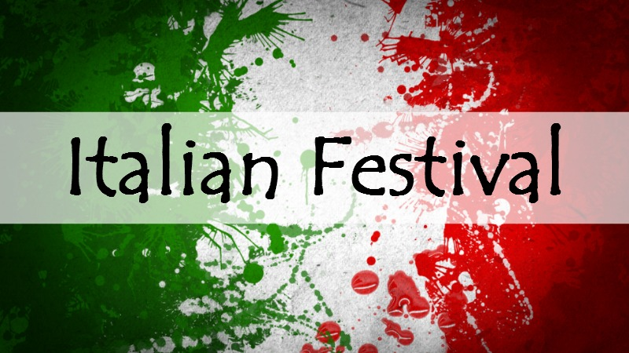

FOR IMMEDIATE RELEASE

CONTACT:
Jon Bruno, 724-249-7660, brunofamily2@comcast.net
Debi Nicolella, vwragtop5@yahoo.com
.

ITALIAN HERITAGE FESTIVAL TO BE HELD
SATURDAY, SEPTEMBER 28, IN DOWNTOWN WASHINGTON

Kick-off spaghetti dinner and concert on Friday, September 27

WASHINGTON, PA, September 1, 2019 ….The fourth annual Washington Italian Heritage Festival is scheduled for Saturday, September 28, noon to 9 pm, at the Community Pavilion on 139 South Main Street in Downtown Washington.

A kick-off event will be held on Friday, September 27, from 5:30 to 9 pm, at the Community Pavilion. Spaghetti dinner is 5:30 to 7 pm. The Tony Janflone Jr. Duo performs from 7 to 9 pm. Tickets for the spaghetti dinner ($10 adults; $8 children 8 and under) must be purchased in advance (seating is limited). Beer and wine will be sold.

The September 28 festival will feature activities for all ages, including face-painting, Clipper the Clown, caricatures, bocce tournament, and a tiramisu tasting. Chef Jason Capps from Canonsburg’s Bella Sera restaurant will provide a cooking demonstration. A & M Winery will host a wine competition.
Sandy Mesler Dance Troupe and the Allegro Dance Company will perform Italian folk dances. Musical performances include the Washington Jazz Orchestra, the acapella group from West Liberty University, guitarist/mandolinist Jimmy “Egidio” Faiella, and festival favorite Nick Fiasco crooning the legendary songs of Frank Sinatra, Dean Martin and other greats.
Throughout the day, guests can enjoy Italian music by DJ Jon Ridge, learn about local Italian clubs, shop for Italian merchandise and, of course, enjoy Italian food. Culinary specialities will be offered by Blue Moon Sweet Shoppe, Chicco Baccello, Christina Pastries, Grande Jr. Pizza Express, Julian’s Catering, Palazzo 1837 Ristorante, Regional Flavors Catering, Union Grill, and Sons and Daughters of Italy. Fudge, desserts and homemade cookies will also be available. Over-21 beverages will be for sale with products from The Washington Winery, J & D Cellars, Red Pump Spirits, Liberty Pole Spirits and The Beer Store.
Representatives of the Italian Heritage Collection at Citizens Library will be on hand to invite descendants of Washington’s Italian immigrants to record oral histories and to digitize historic photos and documents. On-site digital scanning will be available at the festival, courtesy of Citizens Library. Bring your family tree.
Local elected officials participating in the event include State Senator Camera Bartolotta, County Commissioner Larry Maggi, County District Attorney Gene Vittone, and Washington Mayor Scott Putnam.
Senator Bartolotta will recognize this year’s Italian heritage honorees – the many Italian barbers past and present who have been a mainstay of the community. For most of the last century, Washington’s business districts were lined with Italian barber shops. Today, just a few remain.

One of the barbers carrying on the Italian barbering tradition is Sonny Spossey, former mayor of Washington, who retired from his West Chestnut Street shop this summer. The Italian Heritage Collection at Citizens Library is in the process of recording Mayor Spossey’s oral history as the grandson of Italian immigrants and son of the late barber Louis Spossey.

Other barber honorees will include Don Zenner (original Italian name “Zenone”), the grandson of Italian immigrants and son of late barber Frank Zenner; Rich Sonson, grandson of Italian immigrants, who operates Rich’s Barber Shop on West Chestnut Street; Floyd Marasco, who operated a barber shop with his brother Gene in Tylerdale for many years; and Carmen Alberta of Carmen’s Hairdressers.

Other well-known names in local Italian barbering will be recognized, including D’Allessandro, Russo, Miscio, Tocci, Lucatorto, Luppino, Dessaro, Cancelmi, Ciletti, Resciniti, Desensi, Belcastro, Cimino, D’Agostino and Gross.

The festival is sponsored by the Primo Italiano Lodge #2800, Grand Lodge of Pennsylvania, Sons and Daughters of Italy. The group promotes Italian social and cultural events, and supports the Washington community through events and a college scholarship program for eligible students.

Festival sponsors will be recognized in the event program and with signs throughout the festival.

For information about the September 28 festival (including sponsorship and vendor inquiries), contact Jon Bruno, (724) 249-7660, brunofamily2@comcast.net or Debi Nicolella, vwragtop5@yahoo.com. For tickets to the September 27 spaghetti dinner, contact Tom Notaro, 724-222-1170, tomnotaro@comcast.net.

The Facebook page for the festival can be found at https://www.facebook.com/WashPaItalianFest/

#####

FESTIVAL SCHEDULE*

All Day DJ Jon Ridge. Food, drink and vendor booths. Bocce court.
Digital scanning of Italian immigrants’ photos and documents. Face Painting. Caricatures. Mandolinist Jimmy “Egidio” Faiella.

Noon Opening Ceremonies featuring local dignitaries;
blessing by Rev. Michael John Lynam, STL; Pledge of Allegiance by Young Marines

1:30 pm Italian Heritage Recognition of local Italian barbers

2:00 pm Bella Sera Cooking Demonstration

3:00 pm Tarantella Italian Folk Dance, Sandy Mesler Dance Troupe

4:00 pm West Liberty University Acapella Group

5:00 pm Italian Folk Dances, Allegro Dance Company

6:00 pm Washington Jazz Orchestra (Italian and jazz favorites)

7:00 pm Performance by Singer Nick Fiasco. Favorites by Frank Sinatra, Dean Martin and other greats.

- Performers and times subject to change.

