Frank Insana,
Son of Gabriel Insana & Concetta Catanese

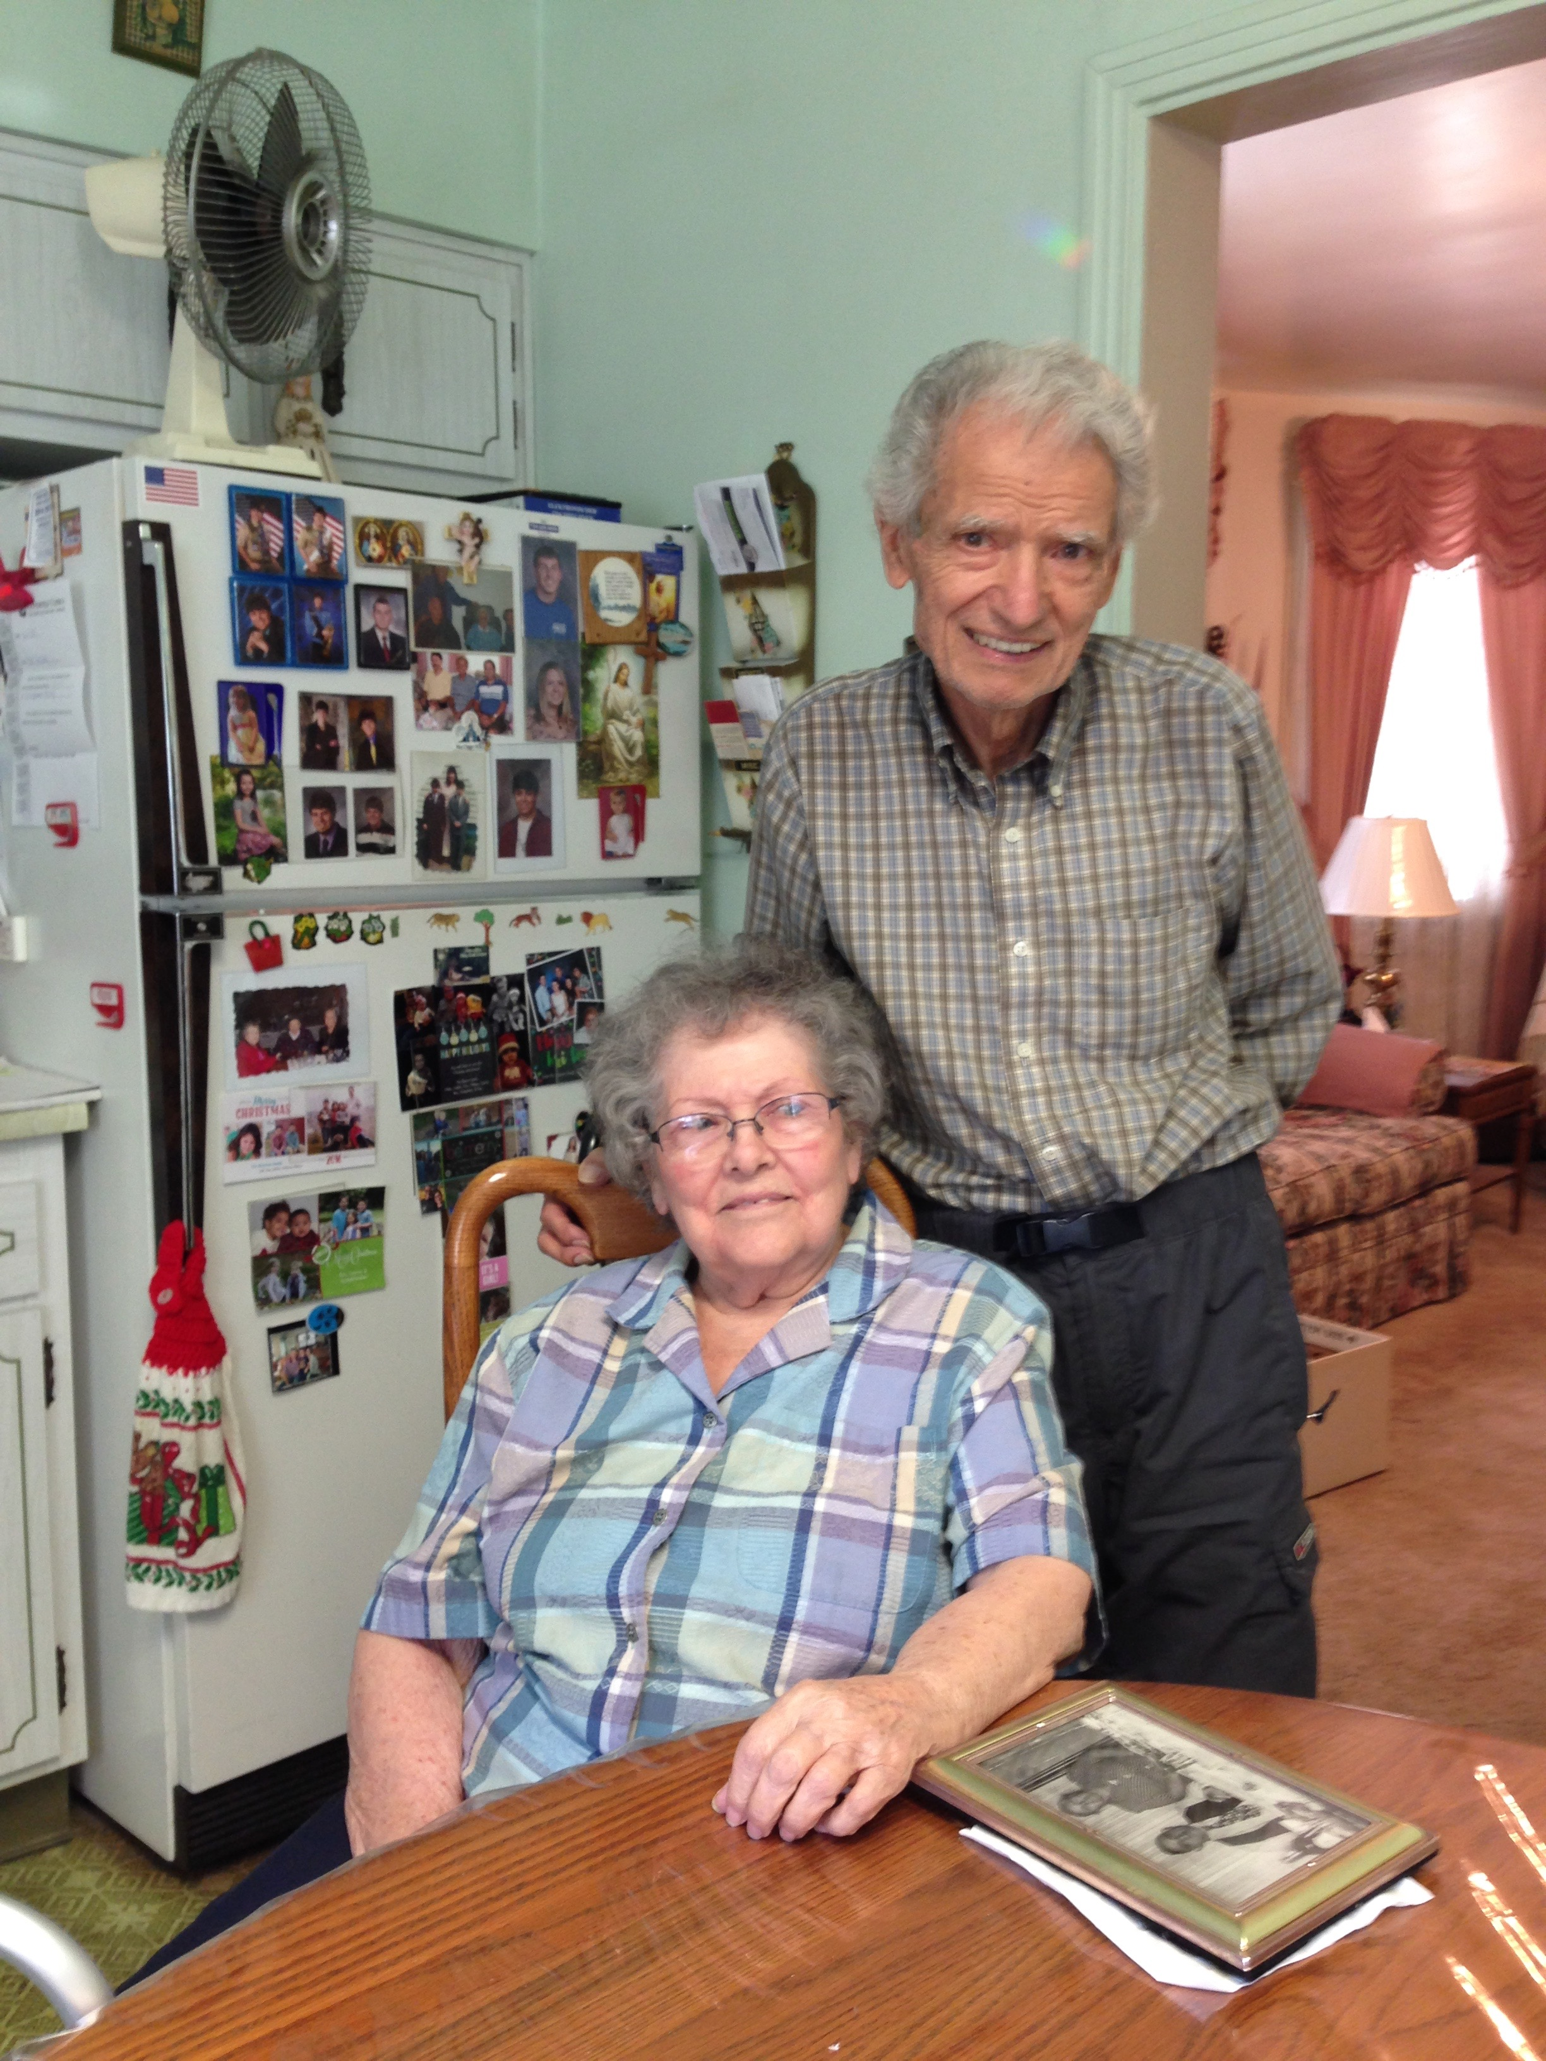
Frank and Jean Lucciola Insana.

This is an interview with Frank Insana, who grew up on South Street in Washington, PA, a veritable Italian village where families were known for helping one another.

Frank’s father, Gabriel Insana, emigrated to Washington as a young man with his father, Antonio, and brother, Frank. They had a cousin in Washington who helped them find work in coal mines. When Gabriel’s brother Frank got the flu and died, it prompted a return to Italy. Gabriel, however, decided to return to Washington once again and make a go of it. He married Concetta Catanese in Sicily in 1920. Concetta was pregnant with their first child, Mary Ann, when she arrived in the United States in 1921.
Frank describes his father as a hard working man and very strict with his children. During Gabriel and Concetta’s early years in Washington, their luck with houses was lacking. The roof of their first house on Woodland Avenue in Tylerdale -- barely more than a shack -- caved in. They saved money to build a better house on nearby Ohio Street, only to see it burn down during a botched neighborhood burglary. Good fortune struck when the Insana family found a home at 64 South Street, a congenial neighborhood that would become home for the extended Insana family for nearly 90 years.

Gabriel was one of the founding members of the Alpine Lodge #9, Washington. Concetta was a healer. She was a member of the Ladies Auxiliary of Victoria Lodge #76. Concetta had eight brothers and sisters, all of whom remained in Italy, as did her parents. In addition to his brother Frank, Gabriel had a brother Dominick, who settled in Cleveland.

Although Gabriel and Concetta faced their share of struggles as immigrants, they also found many things in their favor. Coincidentally, their son Frank’s nickname is “Lucky,” a moniker that proved to be true many times over in his lifetime. Before Frank was born, his father made the bold decision to take a chance on making a life in Washington instead of permanently remaining in Italy with his father. As a boy, Frank pulled a wad of cash from a burning mattress on Ohio Street. As a young man, Frank gained permission to date his future wife, Jean, when her father mistook him for his more well-to-do cousin. Now in his 90s, Frank and his wife Jean live a rich and full life in the warmth of the Italian neighborhood where he grew up.

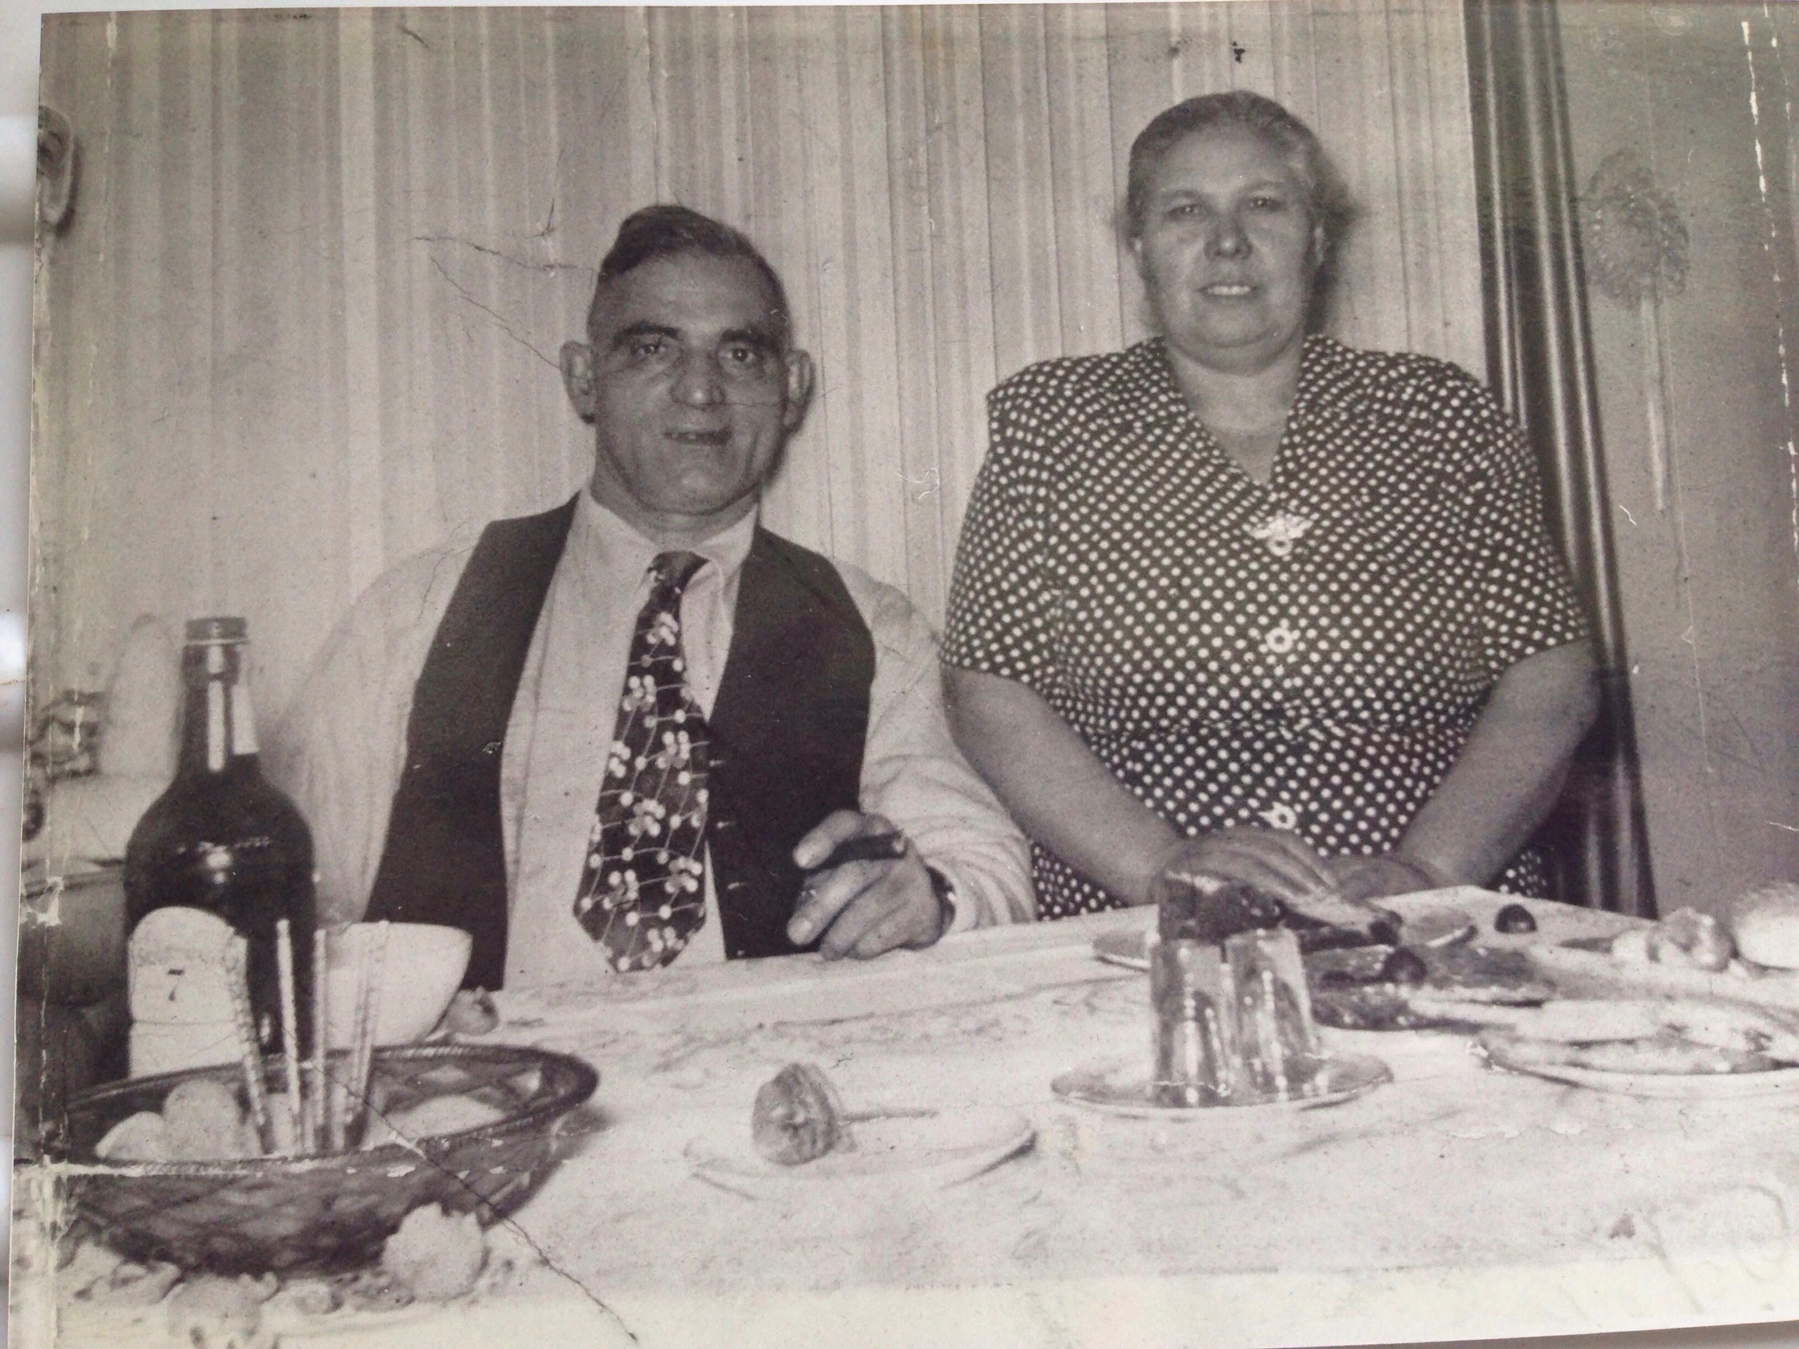
Gabriel and Concetta Catanese Insana.
Family of Frank Insana, b. 8-3-1926, Washington, PA

Frank’s Father:
Gabriel Insana, b. 10-9-1891, San Pier Niceto, Messina, Sicily; d. 11-11-1980, Washington, PA

Frank’s Mother:
Concetta Catanese, b. 10-9-1891, San Pirnigeto, Messina, Sicily; d. 5-14-1957, Washington, PA

Gabriel and Concetta’s date and place of marriage:

1-20-1920, Sicily

Gabriel and Concetta’s Children:
Mary Ann Insana Roux, b. 11-29-1921; d. 2-13-1999; m. Robert Roux, b. 11-14-1919; d. 2-10-1969
Anthony V. Insana, b. 4-3-1923, Washington, PA; m. Georgette
Anna D. Insana LaSalvia, b. 12-4-1924, Washington, PA; d. 8-4-2013; m. Carmon C. LaSalvia, b. 10-10-1917; d. 3-31-1990
Frank J. Insana (see above)
Carmella (Nancy) Insana Fish Podboy, b. 3-25-1932, Washington, PA; m. Carl W. Fish, b. 2-17-1927; d. 2-22-1983; also married Russell D. Podboy, b. 12-14-1919; d. 1-4-2012

Frank’s spouse:
Jean Lucciola, b. 1-10-1929, Canonsburg, PA

Frank and Jean’s Date and Place of Marriage:
1-22-1950, St. Patrick Catholic Church, Canonsburg, PA

Frank and Jean’s Children:
Gabriel Insana, b. 7-27-1952
David Insana, b. 3-9-1955
Diana Insana Mooney, b. 9-5-1961

Frank’s Paternal Grandparents:
Antonio and Maria Sano Insana

Antonio and Maria’s Children:
Frank (died here from flu)
Gabriel (see above)
Dominic (lived in Cleveland)

Frank’s Maternal Grandparents:
Frank and Anna Previta Catanese

Frank and Anna’s Children:
Concetta Catanese Insana (see above)
Frank
Peter Catanese, m. Carmella
Samuel
Joseph
Mariano
Rose
Ann
Frances

Interview

Date, Time and Place of Interview:

July 16, 2017; 11:30 am; 60 South Street (home of Frank and Jean Insana)

Interviewers:
Tina Calabro

Others Present:
Diana Insana Mooney (daughter)

Transcriber:
Liz Terek

Tina Calabro: Let’s start out with some basic information. Where were you born?

Frank Insana: Over here in America. When my Dad [Gabriel] came over, he got hooked up with another Insana, who owns a garage.

TC: What’s his name?

FI: Frank and Esther Insana.

TC: Were they cousins?

FI: Yes. Their fathers were first cousins. [Gabriel and Frank] were second cousins.

TC: Did your father [Gabriel] come here by himself?

FI: He would come over here with his brother, Frank and dad, Antonio. They’d work the coal mine. In the coal mine, it was about only three feet high. They’d work on their knees. His brother [Frank], on one of the trips here, got the flu and he died. That’s when they all went back to Italy. Then, my dad [Gabriel] came back. He’d

wanted to stay here on one of the trips. His father was taking him back to Italy and my father said he wanted to stay here to see if he could get a job. He [Gabriel] went to an Italian boarding house. They were all Italian. He’d stay here, work in the mine, then go back to Italy.

TC: Do you know what street the boarding house was on?

FI: No. I just got this off of him. He didn't talk too much. My dad was very strict. My brother and I were sort of wild. But we didn’t dare to challenge him. He was law and order. We were afraid of him, actually. Both of us were. I wasn’t the youngest, but I was always kidding around with my sisters. There were five of us. I always made jokes. For example, my mother would clean broccoli. I saw her clean it, running water on it. Back in those days, they didn’t have any way to get those little bugs off the vegetables.

Diana Insana Mooney: Pesticides.

FI: Yeah, they didn’t have that. She’d have it in boiling water and that. But if I’d find one, I’d yell, “I found one!” Then nobody wanted to eat whatever my mother cooked. My dad would say, “You come here. Sit right by me.” He’d hit me to be quiet. See, I was the agitator. Nancy was the youngest.

TC: There were 3 brothers that came over here to the United States. Frank, your dad [Gabriel], and Dominic?

FI: I never knew that Frank. My father would visit Dominic in Cleveland.

TC: Did your father have any other brothers or sisters in Italy?

FI: No, I don’t know any other.

TC: Jean, did you have an occupation?

Jean Insana: I was a seamstress and worked at the hospital.

DIM: You were a seamstress at Bobbie Brooks. Then, when that closed down, you went to the hospital.

JI: I worked at the courthouse first. Then, from there, I went to Washington Hospital.
(At Bobbie Brooks) I did the hemming part.

DIM: She used to make me a lot of clothes.

TC: Frank, you said that you worked at Brockway Glass. How many years did you work there?

FI: 40.

TC: What did you do there?

FI: I ended up as a quality control inspector. They offered me a foreman’s job three times. I turned it down.

TC: You retired as a quality control inspector.

FI: Yeah, I started there when I was 16.

TC: Frank, were you in the military?

FI: Yes, I was during the Second World War.

TC: What year did you go into the service?

FI: I got drafted. I was 18. But, they turned me down first. I always had a red mark on my completely flat feet. I got drafted again for the Korean War and was told by the draft board that anybody who could walk or crawl was going. I was sent to Fort Knox, and when they went on a long march, I’d fall out because my flat feet hurt my ankles. I had a good sergeant. He was Indian. He’d looked like my brother- black hair, dark skin. He’d offer me a pint a whiskey. He took to me. Nobody gave me any problem.

TC: Were you in the Army then?

FI: Yes. They later gave me a medical (honorable) discharge again because of my flat feet.

TC: How did your mom and dad meet?

FI: My dad was a smart man. When he was in the coal mines, he said, “I’m working like an animal here.” You only got paid in carts you’d fill up. But for a guy who didn’t get an education beyond fifth grade, he was a smart man. The coal mine owner asked if anybody knew how to drive a car or truck. My dad put his hand up. He said he’d driven Italian cars. He never knew how to drive. But he wanted out of the mine. The coal mine owner later fired him because he drove too fast. My dad later went back to Italy when the Italian government offered to pay for the trip if he enlisted in the Italian army. While at the front line, a sergeant came by and asked if any of the infantry men knew how to drive, and my father raised his hand. So his sergeant said, “Pack your stuff. You’re going to the Mobile outfit.” He sent him back from the front.

TC: Let’s talk about your dad. He went back and forth (between Italy and the United States). Do you think he met your mother over there?

FI: Oh yeah. They got married over there.

TC: Did they have any children over there?

FI: My oldest sister, Mary. My mother was pregnant [with Mary] coming over on the boat. But, she [Mary] was born in America.

TC: Do you know anything about your mother’s family?

FI: My grandmother was Maria. We have pictures of her. She looked like a nurse. She had a white uniform on. She was a good-sized lady. I think she was watching somebody over there in Sicily.

TC: Was she from Sicily?

FI: Yeah. They married over there.

TC: She was from Messina also. Do you remember what year your oldest sister was born?

DIM: November 29, 1921

TC: You said that your dad came here because of Frank Insana, the second cousin who was already here.

FI: He said the first chance he had, he was coming to America, to make some money. The family wanted him married. He went back to Italy. That’s where he courted my mother. My mother’s side was a little well-to-do. My dad’s side was very poor.

TC: Did any of your mother’s family come here?

FI: Yes. She had a big family.

JI: The uncle came.

DIM: Pete was his name. He was [Concetta’s] younger brother. Aunt Carmella and Pete Catanese.

FI: She had a lot of brothers and sisters.

TC: What did Gabriel do in Washington?

FI: Somehow, one of the relatives told him to come to Little Washington. That was the Insanas. They stayed in a little shack.

JI: On Woodland Avenue.

FI: Yeah, somehow they got [Gabriel]) in a factory over here.

TC: At Brockway?

FI: Yeah, but before that, he worked as a laborer. He helped build the Washington Trust Building. They stayed in a little beat-up shed. That’s what my mother told us. It wasn’t very big.
TC: When he brought your mother over they stayed in that house?

FI: Yeah.

TC: That was Ohio Street?

FI: It was off of Ohio Street. One of the alleys where the junkyard was. They eventually built a house there. There’s a story behind that. My dad saved his money. He built a house there on Ohio Street and next door was Joe Colosi. He was a paesano. He was a very good friend of ours. Somehow, we were at a christening up on Glenn Street. Pete Insana was christening a kid. Someone came in and said, “Hey, there’s a house on fire on Ohio Street!” My dad put us all in the car.

When we got there, our house wasn't on fire. It was the house next door. Joe Colosi, he was the treasurer of the Alpine [Lodge #9], and somebody tried to rob him--a father and a son. They knew all the Insanas were up on the hill [Glenn Street] for the christening. After [the robbers] cleaned it out and found whatever they wanted, they torched it. [They had] a five gallon can and they were throwing gasoline. Well, my mother would can, and she had one of those little pots on a pilot light on a little plate. The [robbers] didn’t know. They were throwing gas. When all those fumes eventually got to that [pilot light], Boom! That gas got on both of them. They found the father dead in the cellar and the son they didn’t find until a day later. He was further down, in the back yard. It killed both of them. The firemen were putting water on my dad’s house. A train came by and cut the hose. No water was spraying on my dad’s house. So it caught on fire.

TC: You mean they (the robbers) died from the fire?

FI: Yeah ‘cause they wanted to burn the house down. They’d lived in the boarding house across the street. They figured they could rob and torch it. No one would be the wiser.

TC: How old were you when this happened?

FI: I think I was 5 years old. Now, my dad had that house. He didn’t have it paid for.

TC: Were you born in that house?

FI: Let’s see. That’s where I was born- down there.

TC: So, Mary and Tony were born there?

FI: Yeah.

TC: Annie was born there.

FI: Annie was next and then I came in. Then Nancy, the youngest.

TC: Nancy was born there, too?

FI: I think, yeah, because my dad had that house built.

FI: My dad had to walk from Ohio Street – that’s Tylerdale -- to [Hazel Atlas #1 on South Main Street] every morning. He did work with his hands. My dad was a strong man. He did a lot of labor work.

TC: Do you remember what year the fire happened?

FI: I was five and I was born in 1926.
TC: So, 1931. Did your dad build the second house?

FI: No. He wanted to get away from having to walk from Ohio Street. There was a house for rent. It was only a two-room house- one room downstairs, little kitchen, same upstairs. He said he had five kids and would split the rooms.

TC: Did he rent the house or buy it?

FI: He rented it.

TC: It was two doors down. Did it have a South Street address?

FI: Yeah, South Street.

TC: The number?

FI: No, all I remember, we had five kids there. Mr. Rocco felt sorry for my father. Dad said we’d make it last. He really wanted to get up here. In one room upstairs, he had put a curtain down the middle. There were two rooms up there. One was his room. We kids shared the other one. My sisters on one side. We didn’t dare look on the other side, me and my brother.

TC: So you grew up there?

FI: Yeah, that’s where we grew up. My dad was a hard-working man. [My brother] Tony and I were hotheads. He was almost three years older than me.

DIM: Well, when did you move into this house (Frank’s current residence)?

FI: When I got on at the factory. That’s later on. During the war, they drafted everyone [age] 45 and down. Then, they got to me and the high school kids. I was a senior and I was 12 B. You had to be in 12A. So, I went to Miss Sickle, my homeroom teacher and said, “I’m quitting.” She said, ‘What! Don’t quit. Let me check your schedule.’ They treated me really great.

TC: Was this Wash High?

FI: Yeah. I told [Miss Sickle] that I was quitting ‘cause I got orders to go to the Army. I was 18! She changed my schedule to get me from 12B to 12A. She got me deferred for 3 months. As soon as you pass into 12A and you’re 18, you go. They were waiting on me. That’s what happened. It all worked my way. People were very good to me.

TC: There was an elementary school around here. Did you go to elementary school?

FI: Just 1st Ward.

JI: There was a 5th Ward.

FI: Before our house burned down on Ohio Street, we were on Woodland Avenue. It was a spooky house. My brother and I would holler, “Hey, we heard a noise up here!” It was a shack, is what it was. My dad said, “Yinz be quiet!” He come up with a hammer and nail, and nailed the door shut. We stayed there, then, all of a sudden, we heard a big bang. The whole ceiling downstairs fell down! There was all them bugs in there -- running all over the place. “Get your clothes! Blankets on!” We walked from Woodland Avenue down to Allison Avenue where Joe Colosi lived. Pounded on the door. [Joe Colusi] said, “What happened? Come on in. You boys double upstairs.’ He had two boys and he had a girl. Their girl bunked with ours, put a blanket down the middle for the boys there.

TC: What else can you say about your dad?

FI: We never challenged Pap. Pap gave an order, we did it. Dad would tell Tony, “You watch your brother. If he gets hurt, I’m coming after you.” My brother, Tony, told me later on why he used to say he couldn’t take me with him. He never wanted me around. I’d be madder than hell. Then, I’d walk around the curb and I’d find money. Eventually, they nicknamed me “Lucky.” Another time, my mother’s talking to an old lady across the street. She’s burning a mattress. I looked in and my mother told me to get away. I took a stick and I’m picking. I see what looks like a handkerchief. I knocked it out of the fire and I opened it up. A wad of money. I pulled my mother. She said, “What do you want? Where’d you get that money?” I said, “Outta that mattress. It belonged to that lady.”

TC: What was your mother like?

FI: My mother was a very nice lady. Typical Italian, short, black hair. Very friendly. She was a perfect mother. She always stuck up for the kids.

TC: Did your parents speak Italian?

FI: Oh yeah. We all did, except Nancy never did.

TC: The whole family spoke Italian.

FI: We all talked Italian. We were going to school, we’re talking Italian. They had to send Annie back. Me, I picked up a little American from Ohio Street up Goat Hill. That’s where I went to school. Annie talked all Italian. My mother talked all Italian to us.
My dad said, “You try to talk American to them so they know American not Italian!” Eventually, we picked it up.

TC: Your dad had to learn English because of working.

FI: Oh, yeah. He was a hard-working man.

TC: He learned to speak English pretty well.

FI: No. He had broken English. But, he made friends with people. He was a very friendly man, my dad. But, he was strict as hell. Oh!

TC: Your neighborhood, over on Ohio Street, was it an Italian neighborhood?

FI: Yeah.

TC: When you moved to 64 South Street, was this an Italian neighborhood?

FI: Yeah, because you had the Pacillas, Albanos--these are all Italians here.

FI: My dad saw this house and right away told my mother he wanted to buy it.

TC: And is this house [60 South Street] you were given when you got married?

FI: Yeah.

TC: Did your mom and dad stay over there [at 64 South Street]?

FI: Yeah. They were over there. We were all in a row.

DIM: Aunt Mary lived down the street.
FI: Yeah.

DIM: The house is torn down, but, she lived five houses away, down the street.

JI: Pacillas lived next door.

TC: So what was it like to be in this Italian neighborhood? Were there traditions? How did people get along with each other?

FI: Well, everybody who was Italian here got along with my family. Mr. Rocco Proia (landlord) told all his kids, “You don’t bother this family.” They treated us real good.

DIM: Didn’t you have a garden?

FI: Oh, yeah. Mr. Rocco had land up in Nokomis Park across from Trinity. He gave my dad a stretch of land. He said, “You can put a garden in, Mr. Insana.” He made a homemade wagon. We pulled it up there.

TC: So you’d walk over there to attend to the garden?

FI: Oh, yeah, we’d raise tomatoes, peppers. Anything.

TC: Did you help?

FI: Oh, yeah. You had to work.

TC: You said your mother canned.

FI: Oh, yeah, she canned everything.

TC: Was she a good cook?

FI: Oh, yeah. When I married [Jean], in 1950, she was cookin’ for me. Hamburgers! I couldn’t even eat ‘em! But, I didn’t say nuthin’. Then, I looked at her. I said, “Hey, hun, when you see my mother cooking down there, go down there and watch her.” This is the God’s truth. I give her credit. She watched my mother. She ended up cooking like my mother. The food that I was used to, she picked it up.

DIM: ‘Cause her mother died when she was 11.

TC: So you had to help take care of the family?

FI: Oh, she’s got a big family.

JI: My dad, he took care of the family. As for me, I only went to school. Canonsburg High School.

TC: How did you two meet each other?

FI: I was down at the carnival at Canonsburg -- me and I think it was Adam Ray. We went to carnival just to fool around. We were standing there. It was on a weekend. He said, “Hey, Lucky, that girl’s laughing at us!” Across the street, they were walking. I said, “Let’s go up the street -- across the street -- and we’ll walk right towards ‘em.” I was always bold. In Washington, I didn’t do anything because it was too close to home. Dad would’ve beat the hell outta me. I tried to get her address. She told me. I had to get her to repeat it. I said, “Oh, you’re down by St. Patrick’s Church. You go down that hill.” She said yeah, so I came down. I made a date to take her to a movie. I got down to the railroad track. I thought, ‘What if she gave me a dead end?” I got out of the car and walked. I saw the tracks. I said, “Holy shit!” Then I looked. I saw a road. There was a guy whistling. I said, “Hey buddy! You know where Jean Lucciola lives?” He laughed. He said, “Yeah, go down this street. Third house.” I said OK. It was her brother, Tony. But see, Jean said her dad run everybody out that wanted to date her. But he didn’t run me out. You know why? He checked me out. [He thought] the Insanas got a lot of money. He had the wrong Insanas! He had the ones who owned the garage. My dad was poor.

TC: Did your dad ever tell you what life was like in Sicily? In Messina?

FI: My dad had a real strict dad. This is the truth. My dad would fight him. He’d tie my dad up in the cellar. My grandmother had to come down to feed him.

TC: Were they poor?

FI: Yeah, they were poor. My mother’s side was well-to-do. They owned a nice farm. She had a lot of brothers.

TC: Do you think she was glad she came here?

FI: Oh, yeah. It was paradise compared to Italy. My mother’s side, anything they grew in Messina, was bigger than ours. My mother would always brag about it.

TC: Did they ever tell you how they got over here?

FI: Well, he got a free ticket. Somebody told him, you join the Italian Army. So, he signed up for that. In a month, he ended up on the front. Something hit him. He says to these guys from Florence, “You better quit that.” Boom! Another pebble hits him in the back. He says, “You son of a guns!” His rifle was there. This was on the front line. He went to get his rifle. Before he could turn around, they ran like snakes! They jumped in the weeds and said, “That crazy man’s gonna shoot us!” The sergeant came and said, “What are you going to do--shoot your own people?’ [My dad] said, “I told them to leave me alone. They’re throwing stones on me.” Then, the sergeant gave the guys hell. But you don’t shoot your own men! My dad said OK.

They had to haul the cannons up in the mountains. He’s away from the front. He had to drive up a mountain. A guy with a white patch would tell him, pitch black, and these are cliffs. You go off the road, you’re dead. He would tell you, “Four inches to the right. Hold it.” No light. They were at war. He’d say, ‘Before I got to the top, my hand was shakin’. I don’t think I made it. Then here comes the sergeant. “Congratulations! You passed.” [My dad] was a smart man, but you wouldn’t know he was smart. He didn’t go to school, maybe 5th grade.

TC: It strikes me that your father was a survivor. A person with the ability to adapt and survive.

FI: He knew what to do. I didn’t even know how. You couldn’t communicate with my dad. He was so strict. Over here, I was 18, going to the Army. I had to be in bed at 9 o’clock. Everybody! He went to bed at 9 o’clock; you went to bed. Tony, when he got on shifts, he’d sneak in. He’d climb up by the rain spout. He’d bang, “Let me in.” My dad never caught him.

TC: What kind of father were you? Were you the same or different?

FI: Oh, I treat my kids all equal.

TC: Not too strict?
FI: No. Well, I’m strict. But equal. You listen to me, what I tell you. I don’t hit you for no reason at all. But if you don’t, I’m coming after you. I treat ‘em all fair. All my grandkids respect me. All of ‘em. I don’t abuse none of ‘em. My dad had a mean dad. I heard my dad say, “I had a mean father and I don’t treat my kids like a dog.” That's what he called his father. A mean man.

TC: After your mom and dad got married and settled here, did they keep in touch with the people over in Italy? After they were married, did your Dad go back?

FI: They never went back. He wrote to his parents. My mom did the same to her parents.

FI: They were all strict as hell.

JI: Well, they were old.

FI: They were used to the father eats first at the table. The kids come after. They don’t eat when the father eats. He’s number one. My dad was very fair man. He never abused not one kid. Hit ‘em for nothing. Never!

TC: What did you do for social activities here on South Street?

FI: I wasn’t allowed to go into the street and run around. My dad was very strict. My brother, he had more liberty. He always chased me home.

TC: What kind of games did you play around the neighborhood?

DIM: Baseball?

FI: Yeah, ball. Usually ball.
TC: Who were some of your friends around here?

FI: We were all friendly with all of them. Frank Pacilla. The Rays. That’s who they were running around with.

TC: Did your parents belong to any of the Italian groups?

FI: My dad was in the Alpine [Lodge #9]. He was a founder. One of the originals.

TC: Did he ever talk to you about why they formed the Alpine?

FI: Well, no. He wouldn’t talk about that. See, the Colosi’s were founders, too, and Victor Scepsi (sic). He lived on Park Avenue.

TC: So, these older Italians, they formed the club?

FI: Yeah.

TC: Do you think they formed it as a social club? What was their purpose?

FI: They’d play cards. They’d throw the bocce. They did it for drinks.

TC: It was mostly men.

FI: They did it for the men. You’d win. Your partner’d win. They set you up. My dad was a good card player.

JI: He went to Sons of Italy.

FI: Yeah. When we came up from Ohio Street, he went to Sons of Italy.

TC: Over on Maiden Street?
FI: Yeah.

TC: Did your mom or dad listen to Italian radio shows?

FI: Why, yeah, my mother would more than my dad.

TC: What about Italian newspapers?

FI: He had one coming to the house. I don’t know when he started getting it. I think it was from the club.

TC: Did your parents ever become involved in politics?

FI: No.

TC: What about religion? Did you belong to a Church?

FI: Yeah, Catholic Church.

TC: I.C. Church?

FI: Yeah.

TC: Was going to Church important in your family?

FI: Oh, yeah. We all had to make a Holy Communion and Confirmation. All of us.

TC: Did your parents become American citizens?

FI: Yeah, eventually they did. They had to first learn to talk American.

TC: Your dad didn’t have much of an education.

FI: No. Maybe 5th grade.
TC: And your mother?

FI: Same thing.

TC: But, did they encourage education? Did they want you and your brother and your sisters to get an education?

FI: Oh, yeah. We had to.

TC: Did your parents experience any discrimination in Washington?
Discrimination against Italians?

FI: As far as I know in the neighborhood, nobody did.

TC: Was it hard to get opportunities to work?

FI: Probably for Pap it was. But I wasn’t with him, you know?

DIM: Did your Dad end up working at Brockway?

FI: Yeah. Hazel Atlas, it was. The Insanas got him in.

TC: Did a lot of Italians work at Hazel Atlas?

FI: They didn’t for a while. They wouldn’t hire ‘em. People from Number 2 didn’t like Italians. For some reason. The one who did the hiring lived on Main Street. My dad, around Christmas, made homemade wine. This guy says, “Do you have any wine?” He gave him two gallons or whatever. Then came the “how about you do me a favor?” I think Mary was the one old enough to work. “Can you get her in the factory?” But she got on over at Atlas. Next came Anthony—the hothead. Then Annie. Right down the line. Took all of us.
TC: It sounds like your dad, even though it was hard to get in the factory, he used his brains to advance.

FI: Italians stuck together. You know? You’d fight the other neighborhood if they picked on one guy. They came to the playground. A black kid took my ball. Right away, I got in a fight with him. 6th grade. It was always a black guy always challenging me. I was almost as tall as I am now when I was 13, 14. I grew like a weed and I stopped.

TC: You said the people in the neighborhood, especially the boys, would stick together. You would have conflicts in other neighborhoods. But, what about Italians in other neighborhoods? Did you get along with them?
FI: Well, when they came here. Old hothead, me. Joe Barbella, he said something, did something to me. Right away, I’m fighting him. My brother broke it up. I was ready to fight.

FI: You didn’t mess with somebody in the area. They’d come after you.

TC: Let me ask you one more thing about growing up as an Italian-American in Washington, PA. What are your thoughts about it? What last words do you want to say?

FI: Very good neighborhood. We got in where we had no trouble. We showed respect.

